Honors English 12 Agenda
November 23 – December 4
Monday, November 23, 2015
Please Do Now: Literary Elements Activity
Agenda:
- Read Act III, scene 4,5, 6
- Watch Act III
Homework:
- Act 3 Vocabulary – due Tuesday 11/23
- Unit Test – Monday, December 14
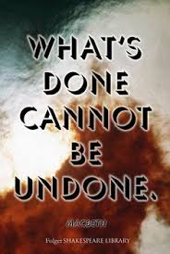
- All journals – due Monday, December 14
- Root word: Tain, Ten, Tent

Tuesday, November 24th, 2015 – Act III Vocabulary due
Please Do Now: Take out your video viewing guide
Agenda:
- Finish watching Act III
Homework:
- Unit Test – Monday, December 14
- All journals – due Monday, December 14
- Root word: Terr, Terra, Geo
- Enjoy your Thanksgiving

Monday, November 30th, 2015
Please Do Now: Take out movie pyramid
Agenda:
- Finish watching Act III
- Act IV anticipation guide
- Read and discuss Act 4, Scene 1
- “Macbeth’s Four Visions”
Homework:
- Act IV Vocabulary due Wednesday, December 2nd
- Unit Test – Monday, December 14
- All journals – due Monday, December 14
- Essay – thesis, subtopics, and evidence – due Wednesday, December 16th – to Google Classroom
- Root word: Therm

Tuesday, December 1st, 2015
Please Do Now: Choose what you feel is the most important scene from the play thus far. Draw a comic book illustration of that scene that captures its importance.
Agenda:
- Read and discuss Act 4, scenes 2 & 3
- Ticket Out: 3 important events from today’s reading, 2 questions you have about what we’ve read, 1 quotation from today’s reading you feel is important
Homework:
- Unit Test – Monday, December 14
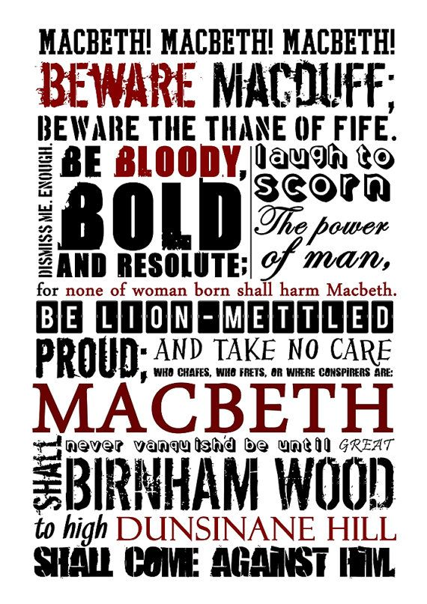
- All journals – due Monday, December 14
- Essay – thesis, subtopics, and evidence – due Wednesday, December 16th – to Google Classroom
- Root word: Tract

Wednesday, December 2nd, 2015 - – Act IV Vocabulary due
Please Do Now: Take out video viewing guide
Agenda:
- Watch Act IV
Homework:
- Unit Test – Monday, December 14
- All journals – due Monday, December 14
- Essay – thesis, subtopics, and evidence – due Wednesday, December 16th – to Google Classroom
- Root word: Vers, Vert

Thursday, December 3rd, 2015
Please Do Now: Predict the ending of the play Macbeth
Agenda
- Read and discuss Act V, scenes 1,2,3
Homework:
- Unit Test – Monday, December 14
- All journals – due Monday, December 14
- Essay – thesis, subtopics, and evidence – due Wednesday, December 16th – to Google Classroom
- Root word: Vit, Viv
Friday, December 4th, 2015
Please Do Now: Write down the statement of theme you are using for Macbeth. Trade with a partner. Is your partner’s theme Shakespeare’s opinion on a topic? Is it refutable? In third person? Broad enough to apply to other texts? Does it have character names in it? It shouldn’t!
Agenda:
- Read Act 5, scene 4,5,6,7
- “Tomorrow, and tomorrow, and tomorrow”
- Ticket Out: After reading the play, in one sentence, answer your literary analysis essay prompt. This could become the rough draft of your thesis statement.
Homework:
- Act V vocabulary due Tuesday, December 8th
- Unit Test – Monday, December 14
- All journals – due Monday, December 14
- Essay – thesis, subtopics, and evidence – due Wednesday, December 16th – to Google Classroom
- Root word: Make sure your root word book is complete – we’re done

