Honors 12 Agenda
February 22nd - March 15th
Lenses of Literary Criticism and Franz Kafka’s The Metamorphosis
Monday, February 22nd
Please Do Now: Read the first sentence of the novelette aloud. Based on the first sentence and the picture cover, write a 1-2 sentence prediction for this novelette. What will this story be about? What themes will be addressed? Will you relate to this story?
Agenda:
- Kafka notes
- Read and discuss “Cipher in the Snow”
- Work on vocabulary assignment / Read Part One and work on guided reading questions
Homework:
- Vocabulary – due Monday, February 29th
- Part One of The Metamorphosis and guided reading questions – due Monday, February 29th
- Part Two of The Metamorphosis and guided reading questions – due Friday, February 26th

Tuesday, February 23 – Thursday, February 25th
Please Do Now: Literary lenses are theories, ideas or methods that readers can use to understand literature and literature-related events. More than one set of theories can be used to understand a literary work and this often results in a broader comprehension of the situations, characters and other related aspects of a particular book. What lenses are you familiar with?
Agenda:
- Lenses of Literary Criticism School House Project
- Research Lens of Literary Criticism
- Read Children’s Book
- Apply Lens of Literary Criticism to the book
Homework:
- Vocabulary – due Monday, February 29th
- Part One of The Metamorphosis and guided reading questions – due Monday, February 29th
- Part Two of The Metamorphosis and guided reading questions – due Thursday, March 3rd
Friday, February 26th
Please Do Now: Hang up your poster around the room and prepare for our gallery Walk
Agenda:
- Lenses of Literary Criticism Gallery Walk and Notes
Homework:
- Vocabulary – due Monday, February 29th
- Part One of The Metamorphosis and guided reading questions – due Monday, February 29th
- Part Two of The Metamorphosis and guided reading questions – due Thursday, March 3rd

Monday, February 29th - Vocabulary due
Please Do Now: 321 Review of Part One (3 important ideas/events, 2 important quotes, 1 question you have after reading)
Agenda:
- Discuss Part 1 based on Guided Reading Questions
- Part I Group Activity

Homework:
- Part Two of The Metamorphosis and guided reading questions – due Thursday, March 3rd
- Vocabulary Quiz – Wednesday, March 2nd
- Common Assessment 3 – Monday, March 7th

Tuesday, March 1st –
Please Do Now:
Agenda:
- Vocabulary Activity
- Finish Part I Group Activity
- Turned in by the end of class

Homework:
- Part Two of The Metamorphosis and guided reading questions – due Thursday, March 3rd
- Part Three of The Metamorphosis and guided reading questions – due Tuesday, march 8th
- Unit Assessment – Monday March 14th, Tuesday March 15th
- Common Assessment 3 – Monday, March 7th
Wednesday, March 2nd
Agenda:
- Vocabulary Quiz
- Read Part Two and work on questions / journal
Homework:
- Part Two of The Metamorphosis and guided reading questions – due Thursday, March 3rd
- Part Three of The Metamorphosis and guided reading questions – due Tuesday, March 8th
- Unit Assessment – Monday March 14th, Tuesday March 15th
- Common Assessment 3 – Monday, March 7th

Thursday, March 3rd – Part Two due!
Please Do Now: Vocabulary Quiz
Agenda:
- Part Two – reading check and questions / journal due
- Part Two discussion – Symbols and “Kafkaesque”
Homework:
- Part Three of The Metamorphosis and guided reading questions – due Tuesday, March 8th
- Unit Test – Friday, March 4th
- Common Assessment 3 – Monday, March 7th
Friday, March 4th
Please Do Now: What lens of Literary Criticism do you think best fits The Metamorphosis?
Agenda:
- Finish Part Two discussion from yesterday
- Kahoot Review, if Time
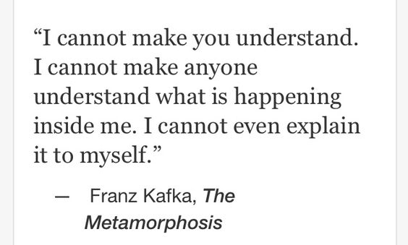
Homework:
- Part Three of The Metamorphosis and guided reading questions – due Tuesday, March 8th
- Unit Assessment – Monday March 14th, Tuesday March 15th
- Common Assessment 3 – Monday, March 7th
Monday, March 7th
Please Do Now:
Agenda:
- Common Assessment 3
- Read Part Three and work on questions / journal
Homework:
- Part Three of The Metamorphosis and guided reading questions – due Tuesday, March 8th
- Unit Assessment – Monday March 14th, Tuesday March 15th
Tuesday, March 8th – Part 3 due!
Please Do Now:
Agenda:
- Finish Common Assessment
- Vocabulary Quiz
- Discuss Part 3 of The Metamorphosis
- Group Discussion

Homework:
- Unit Assessment – Monday March 14th, Tuesday March 15th

Wednesday, March 9th
Please Do Now: What did you like about The Metamorphosis? What didn’t you like?
Agenda:
- Metamorphosis Review
Homework:
- Unit Assessment – Monday March 14th, Tuesday March 15th
Thursday, March 10th
Please Do Now: Open up your notes to the Lenses of Literary Criticism – How many Lenses can you use to read The Metamorphosis?
Agenda:
- Research Lenses of Literary Criticism
- Watch The Metamorphosis

Friday, March 11th – Gym Night Day
Watch the Metamorphosis

Monday, March 14th - Tuesday, March 15th
Introduce Research Paper
Metamorphosis Assessment

