Romeo and Juliet

William Shakespeare

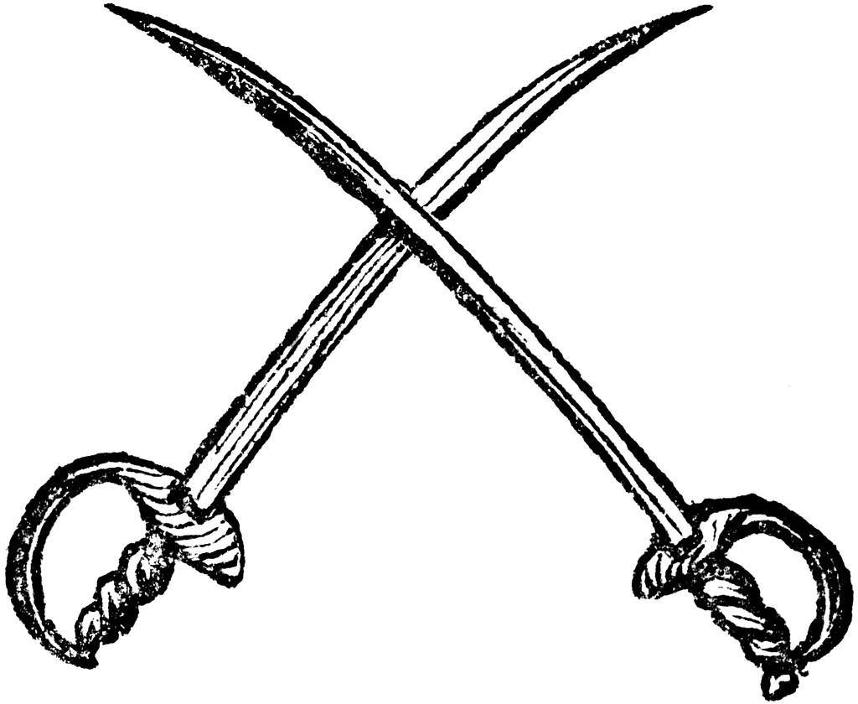

Act 1

ABRAHAM: Do you bite your thumb at us, sir?

SAMPSON: I do bite my thumb, sir.

ABRAHAM: Do you bite your thumb at us, sir?

SAMPSON, aside to Gregory:  Is the law of our side, if I say "Ay"?

GREGORY, aside to Sampson: No.

SAMPSON: No, sir, I do not bite my thumb at you, sir, but I bite my thumb, sir. (1.1.45-52)

Name: _____________________

Teacher: Aubrey Pd: 4

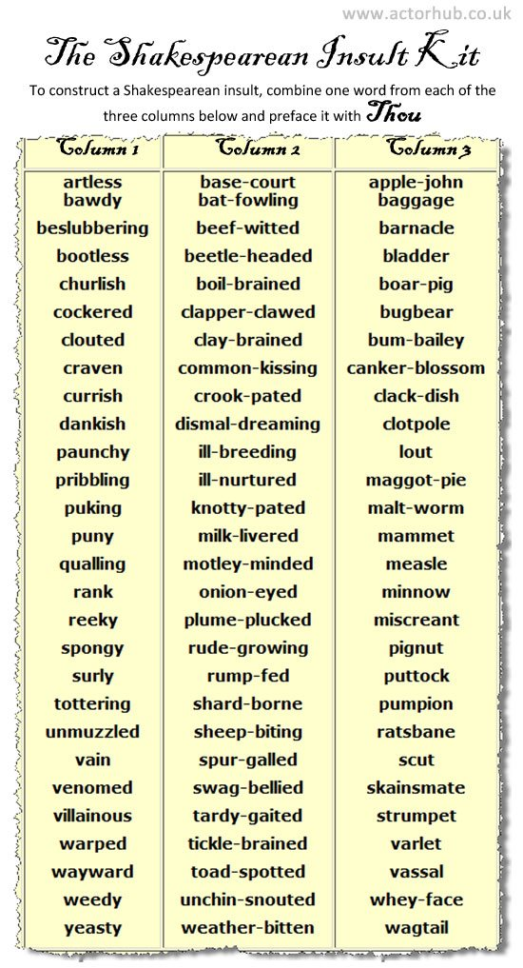

**(Scene 1) Important Events:**

* Tybalt and Benvolio quarrel in the street.
* Prince Escalus declares death to anyone who disrupts the peace again.
* The Montagues and Benvolio learn of Romeo’s distant behavior.
* Romeo is characterized as he reveals that he is hopelessly in love with Rosaline.

**Thinking Like a News Reporter**



**Directions:** To organize their data, news reporters first think in terms of six basic questions. Who was or were involved? What happened? Where and when did it happen? Why and how did it happen? Use the chart below to record information about the street fight at the beginning of *Romeo and Juliet*.

**Basic Question Information**

|  |  |
| --- | --- |
| **Who?** |  |
| **What?** |  |
| **Where?** |  |
| **When?** |  |
| **Why?** |  |
| **How?** |  |

**Poor Romeo!**

**MC900440655[1]**

**Directions:** The last part of Act I, Scene 1, introduces Romeo. Use the graphic organizer to analyze Shakespeare’s initial portrayal of one of the play’s main characters. Include insights based on Romeo’s words and behavior, and give supporting evidence from the play.

**(Scene 2) Important Events:**

1.

2.

3.

**(Scene 2) For Discussion:**

1. How does Lord Capulet feel about the feud at this time of his life? What makes you think this?
2. Why has Paris come to see Lord Capulet?
3. How old is Juliet?
4. What is Capulet’s reply to Paris when Paris asks to marry Juliet?
5. Why does Benvolio want Romeo to attend Capulet’s party? Why does Romeo agree to go?

**(Scene 3) Important Events**

1.

2.

3.

(**Scene 3) For Discussion:**

1. What purpose do Nurse’s ramblings about Juliet serve?
2. How does Juliet feel about getting married? How do you know?
3. Would it be a compliment to be called “a man of wax”?

**(Scene 4) Important Events:**

1.

2.

3.

**(Scene 4) For Discussion:**

1. Find a line that describes Romeo’s mood as he and his friends go to the party. What device was Shakespeare using when he compared “sole” and “soul”?

“You’re wearing dancing shoes with nimble soles. My soul is made out of lead, and it’s so heavy it keeps me stuck on the ground so I can’t move” (Shakespeare 1.4.14-16).

1. According to Mercutio, who or what is Queen Mab, and what does she or it do?
2. What does Mercutio think of dreams? Do you agree?
3. “I’m worried we’ll get there too early. I have a feeling this party tonight will be the start of something bad, something that will end with my own death. But whoever’s in charge of where my life’s going can steer me wherever they want. Onward, lover boys!” (Shakespeare 1.4.106-113). What technique is being used here? Paraphrase the speech.
4. From Romeo’s speech, do you think the Elizabethans believed people had control over their lives or that Fate had things all planned out? How do you know?

**(Scene 5) Important Events**

1.

2.

3.

(**Scene 5) For Discussion:**

1. What lines indicate that Romeo was not really in love with Rosaline?
2. Tybalt’s anger at the presence of a Montague bears out the hot-tempered nature of his character. Give the line that reveals what action he would like to take.
3. What does Lord Capulet’s acceptance of Romeo’s presence tell you about him? What kind of reputation does Romeo have?
4. Explain these lines in your own words: “Go ask his name. If he be married,/My grave is like to be my marriage bed”(Shakespeare 1.5.134-135).
5. What problems do you think are ahead for Romeo and Juliet?

Other Notes/Class Discussion:

*Romeo and Juliet* – Act I Review

1. What does the first scene of the play reveal about Romeo’s behavior? Explain how he changes by the end of Act I.

____________________________________________________________________________________________________________________________________________________________________________________________________________________________________________________________________________________________________________

1. What is your impression of Juliet’s father? Describe the relationship between Capulet and his daughter as it is shown during Scene 2.

____________________________________________________________________________________________________________________________________________________________________________________________________________________________________________________________________________________________________________

1. What concepts of love are presented by the female characters in Scene 3?

____________________________________________________________________________________________________________________________________________________________________________________________________________________________________________________________________________________________________________

1. Characterize Mercutio as he appears in Scene 4. What kind of friend is he to Romeo?

____________________________________________________________________________________________________________________________________________________________________________________________________________________________________________________________________________________________________________

1. What do you learn about Tybalt in Scene 5?

____________________________________________________________________________________________________________________________________________________________________________________________________________________________________________________________________________________________________________

1. Analyze the behavior of Tybalt, Mercutio, and Benvolio in Act I. Based on your analysis, predict what their roles might be in the rest of the play.

____________________________________________________________________________________________________________________________________________________________________________________________________________________________________________________________________________________________________________

1. Compare Romeo’s reaction to Juliet’s when each discovers the true identity of the other.

____________________________________________________________________________________________________________________________________________________________________________________________________________________________________________________________________________________________________________

**Act I Review**

**Literary Elements**

1. A **foil** is a character in literature who has qualities that are in sharp contrast to another character, thus emphasizing the qualities of each. How is Mercutio a foil to Romeo?

____________________________________________________________________________________________________________________________________________________________________________________________________________________________________________________________________________________________________________

1. **Foreshadowing** refers to hints in the text about what will occur later. What examples of foreshadowing do you find in the Prologue and in Scene 4 of Act I?

____________________________________________________________________________________________________________________________________________________________________________________________________________________________________________________________________________________________________________

1. **Hyperbole** means obvious exaggeration. Look at Romeo’s declaration of love for Rosaline in Act I, Scene 1. What examples can you find of hyperbole? Why do you think he overstates his feelings?

____________________________________________________________________________________________________________________________________________________________________________________________________________________________________________________________________________________________________________

1. Good drama has **conflict**: struggle between opposing forces. What conflicts are set in motion by events in Scene 5?

____________________________________________________________________________________________________

________________________________________________________________________________________________________________________________________________________________________________________________________