Romeo and Juliet
Act 4 & 5

“For never was a story of more woe than this of Juliet and her Romeo.” – Prince Escalus

Name: ______________________

Teacher: _____________________

Romeo and Juliet - Act IV
Anticipation Guide

True or False? Dreams can warn us about future events. ___________
REASONING:

Predict who might be most upset if Juliet dies. _________________
REASONING:

Who might be least upset if Juliet dies? _________________
REASONING:

Brought to you by Shmoop.com - we speak student
Scene 1
- He tells Juliet his idea. He knows of a weird potion that will make Juliet appear as if she is dead for "two and forty hours." That's Shakespeare for 42 hours.
- Conveniently, the Capulets don't actually bury their dead in the ground, which otherwise would kind of screw up the plan. Instead, they stick them in a big tomb.
- If everyone thinks Juliet is dead, the Friar explains, she won't have to marry Paris. Then he and Romeo can come to the tomb and wait for her to wake up, and then she and Romeo can go to Mantua together. The Friar promises to send a letter to Romeo so he knows what's going on.
- Juliet thinks this is a great idea, which we can only understand by assume she's never seen a tragedy in her life. She takes the potion, thanks the Friar, and heads home.
Scene 2
- Juliet comes home, all fake-humble and repentant. She apologizes for being a bratty teenager and says she'll marry Paris.
- Lord Capulet is overjoyed and decides the marriage will take place the next day, even if he has to stay up all night making preparations.
Scene 3
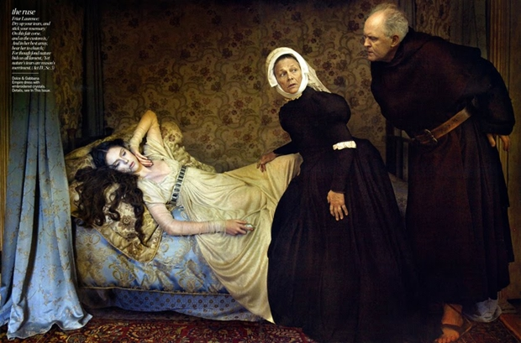
- Juliet convinces the Nurse and Lady Capulet to leave her alone, then takes out the potion the Friar gave her.
- She worries for a brief moment that it might be real poison, and then freaks herself out by imagining what it'll be like to awake surrounded by a bunch of dead bodies, including the fresh corpse of her cousin Tybalt.
- She drinks the potion, making sure to fall on to the bed instead of dropping awkwardly onto the floor.
Scene 4
- Everyone is bustling around cheerfully trying to get things ready for the wedding that morning. No one has realized yet that the bride has a serious case of cold feet
- When the Nurse comes to wake Juliet up in the morning, she discovers the girl dead. Oh, bummer. Wonder if they'll get the photographer's deposit back?
- Then the Friar shows up and takes action, telling them to take Juliet to the tomb, stat.
Catastrophe
- What literary device is evident in the opening lines of act 5, scene 1?

- How does Balthasar ruin the friar’s plan?

- How does Romeo respond to the news of Juliet’s death? Why is his reaction so extreme?

- How did Friar John inadvertently ruin Friar Lawrence’s plan?

- What factors lead Romeo and Paris to confront one another at the tomb? What is the end result?

- What are the main ideas in Romeo’s last soliloquy?

- What is ironic about the friar’s arrival at the tomb? What if he had been just ten minutes earlier?

- Why does the friar leave Juliet alone in the tomb?

- What does Juliet do? Why?

- Is the friar’s lengthy account near the end of the play accurate?

- At the end of the play, what is the status of the family feud?

- How will Romeo and Juliet be commemorated?
Sunday
Monday
Tuesday
Wednesday
Thursday
Friday
Shakespeare's Planner

