Romeo and Juliet
Act 4 & 5

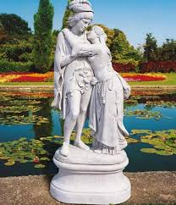

“For never was a story of more woe than this of Juliet and her Romeo.” – Prince Escalus

Name: ______________________

Teacher: _____________________

Romeo and Juliet - Act IV
Anticipation Guide

True or False? Dreams can warn us about future events. ___________
REASONING:

Predict who might be most upset if Juliet dies. _________________
REASONING:

Who might be least upset if Juliet dies? _________________
REASONING:

Scene 1 –
- What is Friar Laurence’s plan for Juliet?

Scene 2 –
- What does Juliet do when she gets home?

- How does Capulet react?

Scene 3
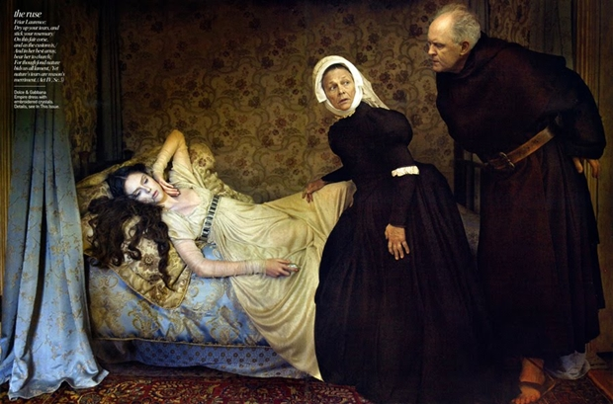
- Juliet convinces the Nurse and Lady Capulet to leave her alone, then takes out the potion the Friar gave her.
- She worries for a brief moment that it might be real poison, and then freaks herself out by imagining what it'll be like to awake surrounded by a bunch of dead bodies, including the fresh corpse of her cousin Tybalt.
- She drinks the potion, making sure to fall on to the bed instead of dropping awkwardly onto the floor.
Scene 4
- Everyone is bustling around cheerfully trying to get things ready for the wedding that morning. No one has realized yet that the bride has a serious case of cold feet
- When the Nurse comes to wake Juliet up in the morning, she discovers the girl dead. Oh, bummer. Wonder if they'll get the photographer's deposit back?
- Then the Friar shows up and takes action, telling them to take Juliet to the tomb, stat.
Act 5 - Catastrophe
- Scene 1 - What literary device is evident in the opening lines of act 5, scene 1?

- Scene 2 - How does Balthasar ruin the friar’s plan?

- Scene 2 - How does Romeo respond to the news of Juliet’s death? Why is his reaction so extreme?

- Scene 1 and 2 - How did Friar John inadvertently ruin Friar Lawrence’s plan?

- Scene 3 - What factors lead Romeo and Paris to confront one another at the tomb? What is the end result?

- Scene 3 - What are the main ideas in Romeo’s last soliloquy?

- Scene 3 - What is ironic about the friar’s arrival at the tomb? What if he had been just ten minutes earlier?

- Scene 3 - Why does the friar leave Juliet alone in the tomb?

- Scene 3 - What does Juliet do? Why?

- Scene 3 - Is the friar’s lengthy account near the end of the play accurate?

- Scene 3 - At the end of the play, what is the status of the family feud?

- Scene 3 - How will Romeo and Juliet be commemorated?
Sunday
Monday
Tuesday
Wednesday
Thursday
Friday
Shakespeare's Planner

