Name: ______________________________________ Date: _______
Honors English 12 Period: _____
Macbeth
William Shakespeare
Act IV
Scene 1

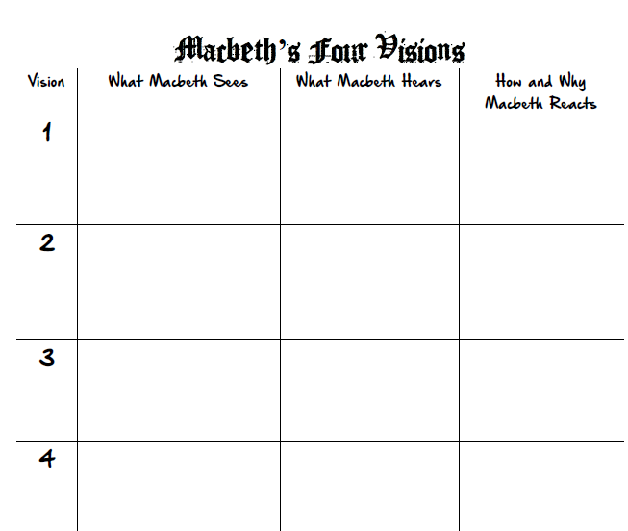

Scene 2 | Scene 3

Literary Analysis: Theme
You should be narrowing down your statement of theme. At this point, start looking for evidence for two themes to determine which theme you think is strongest.

- Ambition
- Impulses and Desires
- Marriage
- Fate and people’s efforts to control it
- Appearance vs. Reality
- Loyalty
- The supernatural
- Reason and mental stability

Statement of Theme:  Evidence (cited): | Statement of Theme:  Evidence (cited):

