***Romeo and Juliet***

**Act III**

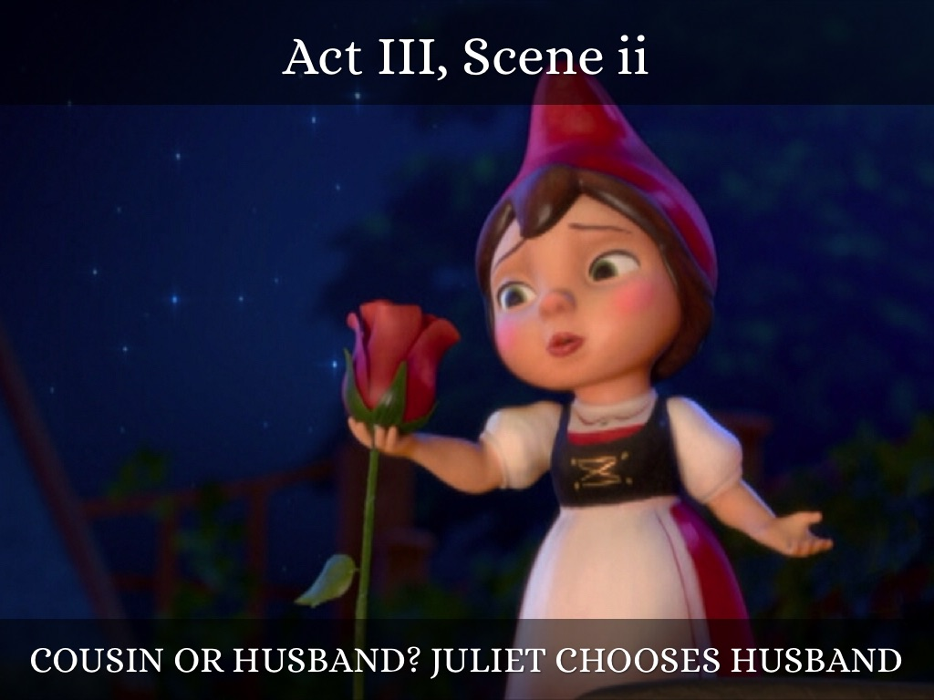

*“A plague o’ both your houses!”*

Name: _________________________________

Teacher: _____________________________

**Anticipation Guide – Act 3**

**True or False**

1. _______ If an adult knows a young person is heading for serious trouble, he or she has a responsibility to tell that person’s parents.

REASONING:

2. _______ Youthful marriages seldom work out well.

REASONING:

**Before You Read:**

* Notice how the mood of the play changes during Act III.
* The influence of the heavens is an important theme in Romeo and Juliet. There are many references to the stars and the role that Fate plays in people’s lives. Elizabethans believed that the stars foretold and influenced events on earth, much as astrologers today do. We have already heard the lovers called “star-crossed,” and Romeo feels there is “some consequence yet hanging in the stars.” Watch for other references to the heavens as you continue to read.
* Dramatic irony occurs when the audience knows something that the character does not know. Identify instances of dramatic irony throughout Act III.

*How it went down –* Act 3, scene 1

*Two murders in a hot, hot day in Verona*

**

1. Who are the first people on the street?
2. Who is the first to approach a member of an opposing group?
3. Who is the first to mention fighting?
4. What does Benvolio suggest?
5. What actually stops an immediate fight between Tybalt and Mercutio?
6. How does Tybalt approach Romeo?
7. How does Romeo respond?
8. How does Mercutio react?
9. What does Romeo do when Mercutio and Tybalt are fighting?
10. What is the result of Romeo’s intervention?
11. What relationship does Romeo see between his love for Juliet and the death of Mercutio?
12. What does Romeo do when Tybalt returns to the scene?
13. How does Benvolio react?
14. In the first act, what decision did the prince announce about the people who fight in Verona? Do you think he will stick with that decision?

**Act III, Scenes 2 and 3 Study Guide**

**C:\Documents and Settings\Kenny Casile\Local Settings\Temporary Internet Files\Content.IE5\TY609DIY\MC900156053[1].wmf**

**Scene 2 Important Events:**

* Juliet learns of her cousin Tybalt’s death and of Romeo’s banishment.
* Nurse volunteers to go to Romeo before he leaves Verona, and Juliet sends her ring as a symbol of her love, asking him to come and see her one last time.

**Scene 2 For Discussion:**

1. At first, who does Juliet think is dead?
2. When Juliet finds out that Romeo killed Tybalt, what is her first reaction?
3. What is Nurse’s opinion of men in general?
4. Once the shock is over, what does Juliet realize?
5. What one word is more awful than Juliet’s whole family being killed?
6. In light of what has happened, what does Juliet plan to do?
7. What symbol of her love does Juliet send Romeo?
8. Where is Romeo hiding?
9. What line reveals Prince Escalus’ decision about Romeo?

**Act III, Scene 3**



**Scene 3 Important Events:**

* Romeo is in despair over his banishment and ready to kill himself, but Friar Laurence points out to him that there is still much to be happy for, and that Romeo should get his wits about him and plan what he will do next.
* Nurse arrives with Juliet’s ring ant the news that she wants to see Romeo, and he is much cheered by this.

**Scene 3 For Discussion:**

1. Would Romeo prefer death to exile?
2. What effect does Romeo’s reaction to the prince’s decree have on Friar Laurence?
3. What news does Nurse bring?
4. What is Romeo afraid Juliet feels?
5. What does Friar Laurence tell Romeo he should be happy about?
6. What does Friar Laurence tell Romeo he should do?
7. What does Nurse give Romeo that “revives his comfort”?

**Act III, scene 4 & 5**

Brought to you by Shmoop.com - we speak student ☺

Scene 4 (not in movie)

* Paris is still hanging around hoping he can marry Juliet.
* Unfortunately, Juliet's still way depressed about Tybalt/ Romeo.
* Juliet's grief for Tybalt seemed so extreme to her father that he's changed his mind about waiting a few years before she is married. What better way to cheer her up than to force her into a marriage with a man she's just not that into?
* Figuring that there's no way Juliet could refuse a great guy like Paris, Lord Capulet decides to go full speed ahead. How about marrying her next week? he asks Paris.
* Sure!

**Scene 5**

* Romeo and Juliet wake after their first and (spoiler alert) only night together.
* They don't want to say good-bye, but they know Romeo will be killed if he gets caught in Verona. (Not to mention in Juliet's bed.)
* Before Juliet has time to fix her hair or anything, her mother comes in. They manage to have a conversation about "that villain Romeo" in which Lady Capulet misinterprets 99.9% of everything that Juliet says.

*Go back into the text – How does Juliet deceive her mother?

* Lady Capulet announces her big, exciting news: in two days, **Juliet will be ____________________________________________________**
* No way, says Juliet, being a typical thirteen-year-old.
* Lady Capulet throws up her hands and basically says "Wait 'til your father gets home."
* When he does get home, he's all pleased with himself for arranging such a great marriage for her, so he's surprised when he rains on his parental-control parade.
* Lord Capulet blows up. When verbally abusing Juliet doesn't work, he tries a different tactic. **What is this tactic?**
* After Lord Capulet storms out, Juliet turns to her mother for help. How could a mother turn her own daughter out of the house? Juliet begs her mother to find a way even to delay the marriage with Paris.
* But Lady Capulet just storms out, too.
* How about the Nurse?
* Juliet makes a case for not abandoning the hubby: She's already married, so marrying Paris would be a sin against God, as well as an unthinkable betrayal of Romeo.
* **What is the Nurse’s response?**
* Unless you count starving on the street which, clearly, the Nurse does not.
* Juliet cannot believe this is happening. Even the nurse isn't on her side anymore.
* Juliet has only one ally left: Friar Laurence. If he can't help her, suicide might be her only option.

