Romeo and Juliet
Act III

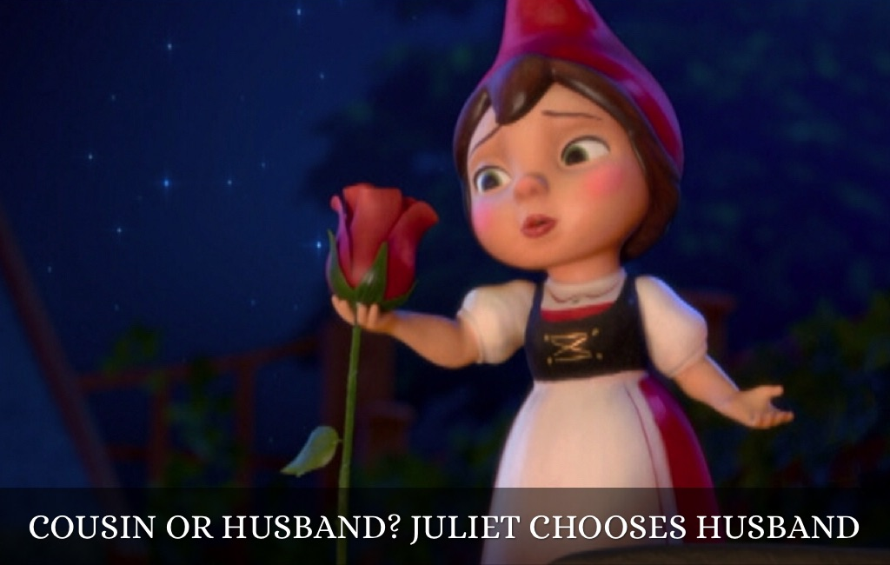

“A plague o’ both your houses!”

Name: _________________________________

Teacher: Aubrey – Period 4

Anticipation Guide – Act 3

True or False

1. _______ If an adult knows a young person is heading for serious trouble, he or she has a responsibility to tell that person’s parents.
REASONING:

2. _______ Youthful marriages seldom work out well.
REASONING:

Before You Read:

- Notice how the mood of the play changes during Act III.

- The influence of the heavens is an important theme in Romeo and Juliet. There are many references to the stars and the role that Fate plays in people’s lives. Elizabethans believed that the stars foretold and influenced events on earth, much as astrologers today do. We have already heard the lovers called “star-crossed,” and Romeo feels there is “some consequence yet hanging in the stars.” Watch for other references to the heavens as you continue to read.

- Dramatic irony occurs when the audience knows something that the character does not know. Identify instances of dramatic irony throughout Act III.

How it went down – Act 3, scene 1
Two murders in a hot, hot day in Verona
- Who are the first people on the street?

- Who is the first to approach a member of an opposing group?

- Who is the first to mention fighting?

- What does Benvolio suggest?

- What actually stops an immediate fight between Tybalt and Mercutio?

- How does Tybalt approach Romeo?

- How does Romeo respond?

- How does Mercutio react?

- What does Romeo do when Mercutio and Tybalt are fighting?

- What is the result of Romeo’s intervention?

- What relationship does Romeo see between his love for Juliet and the death of Mercutio?

- What does Romeo do when Tybalt returns to the scene?

- How does Benvolio react?

- In the first act, what decision did the prince announce about the people who fight in Verona? Do you think he will stick with that decision?

Scene 2 For Discussion:
- At first, who does Juliet think is dead?

- When Juliet finds out that Romeo killed Tybalt, what is her first reaction?

- What is Nurse’s opinion of men in general?

- Once the shock is over, what does Juliet realize?

- What one word is more awful than Juliet’s whole family being killed?

- In light of what has happened, what does Juliet plan to do?

- What symbol of her love does Juliet send Romeo?

- Where is Romeo hiding?

- What line reveals Prince Escalus’ decision about Romeo?

Scene 3 For Discussion:
- Would Romeo prefer death to exile?

- What effect does Romeo’s reaction to the prince’s decree have on Friar Laurence?

- What news does Nurse bring?

- What is Romeo afraid Juliet feels?

- What does Friar Laurence tell Romeo he should be happy about?

- What does Friar Laurence tell Romeo he should do?

- What does Nurse give Romeo that “revives his comfort”?

Scene 4 For Discussion:

- Since Juliet is so sad, what does her father decide will cheer her up? When will his “surprise” take place?

Scene 5 For Discussion:
- Romeo and Juliet wake after their first and (spoiler alert) only night together. They don't want to say good-bye, but they know Romeo will be killed if he gets caught in Verona. (Not to mention in Juliet's bed.)

- Describe the discussion between Juliet and Lady Capulet about “The Villain Romeo”. How does Lady Capulet misinterpret what her daughter is saying? How does Juliet deceive her mother?

- What is Juliet’s reaction when her mother tells her she will be married to Paris in two days?

- How does Lord Capulet respond to Juliet’s defiance?

- How about the Nurse? What is her advice in all of this?

- What does Juliet decide she must do?

Act III Review

Connect to the Literature
- What were your thoughts about Lord Capulet’s behavior?

__________________________________________________________________________________________________________________________________________________________________________________________________________________________________

Think Critically
- Which event in this act do you think causes the most problems for Romeo and Juliet? Why?

- How well do you think Romeo handles difficult circumstances? Provide examples to support your response.

- Describe Juliet’s situation at the end of this act. Provide examples to support your response.

- Compare and contrast the behavior of the Nurse and the Friar in Act III. Which of the two would you trust more if you were Romeo or Juliet? Why?

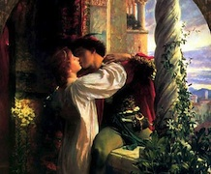

Literary Analysis

- An allusion is a brief reference, within a work, to something outside the work that the audience or reader is expected to know. Shakespeare’s plays, for example, often contain allusions to historical and current events, ancient Greek and Roman mythology, and the Bible. Line 20 from Act III, Scene 5, alludes to Cynthia, another name for Diana, Roman goddess of the moon. Cynthia was often depicted with a crescent moon on her forehead (reflex here means “reflection”):
‘Tis but the pale reflex of
Cynthia’s brow

This allusion has a somewhat chilling, distancing effect, which anticipates the separation that Romeo and Juliet are facing at this point in the play.

---------------------------------------------------------------------------------------------------------------------------------------
Irony exists when there is a contrast between what is expected and what actually occurs. Situational irony occurs when a character or the reader expects one thing to happen but something else really happens. Dramatic irony occurs when the reader or viewer knows something that a character does not know.

Activity: Find an example of each type of irony listed below in Act III:
- Irony:

- Situational Irony:

- Dramatic Irony:

