Name: ___________________________________________ Date: ________
Honors English 12 Period: _______
“Grendel’s Mother” and “The Battle with Grendel’s Mother”

1.1.12.D: Demonstrate comprehension / understanding before reading, during reading, and after reading on a variety of grade level texts to support understanding of a variety of literary works from different cultures and literary movements.
1.2.12.A: Evaluate and critique text organization and content to determine the author’s purpose and effectiveness according to the theses, accuracy, thoroughness, logic, and reasoning
1.3.12.C: Analyze the effectiveness of literary elements used by authors in various genres.

“Grendel’s Mother” (read page 23 until line 28 “Both had lost!”) Although one monster has died, another still lives. From her lair in a cold and murky lake, where she has been brooding over her loss, Grendel’s mother emerges, bent on revenge.

- Line 25 – Why do you think Grendel’s mother takes his claw?

Devastated by the loss of his friend, Hrothgar sends for Beowulf and recounts what Grendel’s mother has done. Then Hrothgar describes the dark lake where Grendel’s mother has dwelt with her son.

"They live in secret places, windy
Cliffs, wolf-dens where water pours
From the rocks, then runs underground, where mist
Steams like black clouds, and the groves of trees
Growing out over their lake are all covered
With frozen spray, and wind down snakelike
Roots that reach as far as the water
And help keep it dark. At night that lake
Burns like a torch. No one knows its bottom,
No wisdom reaches such depths. A deer,
Hunted through the woods by packs of hounds,
A stage with great horns, though driven through the forest
From faraway places, prefers to die
On those shores, refuses to save its life
In that water. It isn't far, nor is it
A pleasant spot! When the wind stirs
And storms, waves splash toward the sky,
As dark as the air, as black as the rain
That the heavens weep. Our only help,
Again, lies with you. Grendel's mother
Is hidden in her terrible home, in a place
You've not seen. Seek it, if you dare! Save us,
Once more, and again twisted gold,
Heaped-up ancient treasure, will reward you
For the battle you win!

- What sort of place is the underwater lair of Grendel’s mother? How does the translator’s use of alliteration make this description more effective?

- Make a prediction. What will Beowulf’s response be to Hrothgar’s challenge at the end of the passage? How do you know?

Extension Activity: What monsters do we have in today’s world? Do you believe Grendel was a real monster in the epic story of Beowulf? If not, why would the writer include a fictional monster in this story?

“Battle with Grendel’s Mother”

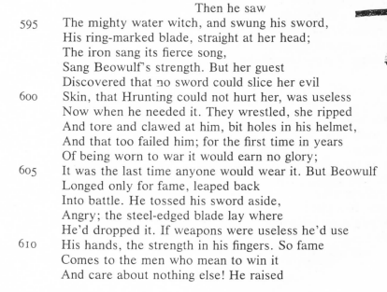
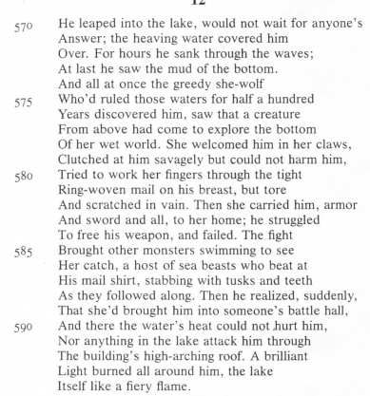
- Lines 610-613– How important is fame to Beowulf?

- Lines 570-574 – What characteristic of an epic hero does Beowulf display in these lines?

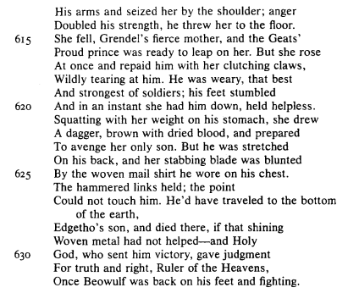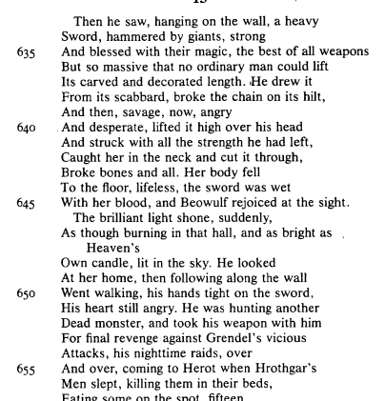
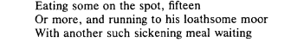
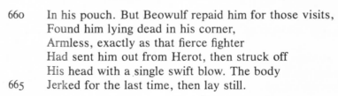

The wise old warriors who surrounded Hrothgar,
Like him staring into the monsters' lake,
Saw the waves surging and blood
Spurting through. They spoke about Beowulf,
All the graybeards, whispered together
And said that hope was gone, that the hero
Had lost fame and his life at once, and would never
Return to the living, come back as triumphant
As he had left; almost all agreed that Grendel's Beowulf Page | 16
Mighty mother, the she-wolf, had killed him.
The sun slid over past noon, went further
Down. The Danes gave up, left
The lake and went home, Hrothgar with them.
The Geats stayed, sat sadly, watching,
Imagining they saw their lord but not believing
They would ever see him again.
—Then the sword
Melted, blood-soaked, dripping down
Like water, disappearing like ice when the world's
Eternal Lord loosens invisible
Fetters and unwinds icicles and frost
As only He can, He who rules
Time and seasons, He who is truly
God. The monsters' hall was full of
Rich treasures, but all that Beowulf took
Was Grendel's head and the hilt of the giants'
Jeweled sword; the rest of that ring-marked
Blade had dissolved in Grendel's steaming
Blood, boiling even after his death.
And then the battle's only survivor
Swam up and away from those silent corpses;
The water was calm and clean, the whole
Huge lake peaceful once the demons who'd lived in it
Were dead.
Then that noble protector of all seamen
Swam to land, rejoicing in the heavy
Burdens he was bringing with him. He
And all his glorious band of Geats
Thanked God that their leader had come back unharmed;
They left the lake together. The Geats
Carried Beowulf's helmet, and his mail shirt.
Behind them the water slowly thickened
As the monsters' blood came seeping up.
They walked quickly, happily, across
Roads all of them remembered, left
The lake and the cliffs alongside it, brave men
Staggering under the weight of Grendel's skull,
Too heavy for fewer than four of them to handle—
Two on each side of the spear jammed through it—
Yet proud of their ugly load and determined
That the Danes, seated in Herot, should see it.
Soon, fourteen Geats arrived
At the hall, bold and warlike, and with Beowulf,
Their lord and leader, they walked on the mead-hall
Green. Then the Geats' brave prince entered
Herot, covered with glory for the daring
Battles he had fought; he sought Hrothgar
To salute him and show Grendel's head.
He carried that terrible trophy by the hair,
Brought it straight to where the Danes sat,
Drinking, the queen among them. It was a weird
And wonderful sight, and the warriors stared.

3. Why do you think the Geats want the Danes to see the monster’s skull?

