Name: ___________________________________________ Date: ________
Honors English 12 Period: _______
beowulf

1.1.12.D: Demonstrate comprehension / understanding before reading, during reading, and after reading on a variety of grade level texts to support understanding of a variety of literary works from different cultures and literary movements.
1.2.12.A: Evaluate and critique text organization and content to determine the author’s purpose and effectiveness according to the theses, accuracy, thoroughness, logic, and reasoning
1.3.12.C: Analyze the effectiveness of literary elements used by authors in various genres.
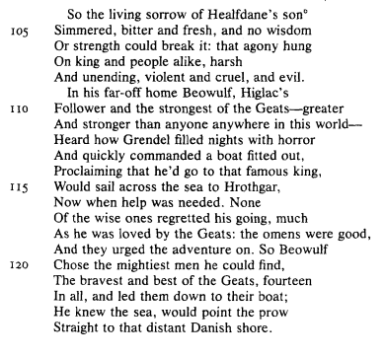

- Summarize the important information in the opening passage about Beowulf (Lines 104 – 141).

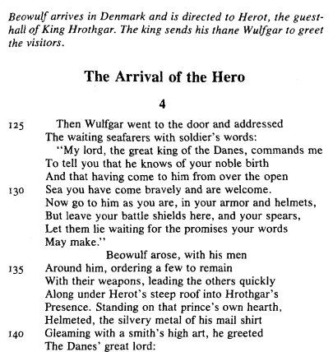

- Lines 110-111: The Beowulf Poet uses exaggeration (hyperbole) to help emphasize Beowulf’s heroism and to give a strong first impression of Beowulf. What effect does this kind of exaggeration have on epic poetry?

- (p. 16) What are your first impressions of Beowulf, based on his opening address to Hrothgar?

- Line 7: What does the poet mean by “Light and life fleeing together”?

- Lines 32-34: Beowulf insists on fighting Grendel without weapons. Why do you think this is so important to him?

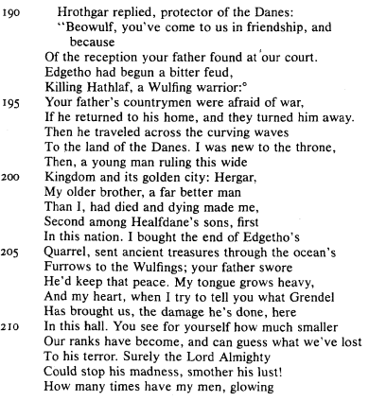

- Lines 191 – 206: What service did Hrothgar perform for Beowulf’s father?

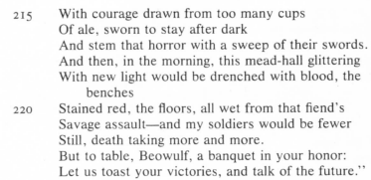
- Lines 210 -221: Hrothgar’s account of the damage Grendel has done provides many examples of alliteration. Locate lines that contain the repetition of an initial consonant sound.

