Name: Date:
English 9 Period:
Mystery Genre Study
Book Talk Assignment

Throughout this mystery unit, you were to read at least one mystery text; you will not complete a Book Talk for a/the mystery book you read throughout the unit. For your Book Talk, you will give a 1-2 minute presentation. The purpose of a book talk is to convince the listener to read the book you are recommending. This book talk is essentially a persuasive speech to convince the listener that they should read a specific book.

A book talk is very similar to a trailer for a film, which shows you just enough information to convince you that you should watch the movie.

The book talk will cover some elements of the novel, but you should focus much of your time on the plot, themes and conflict in the novel. NO SPOILERS!!! (Don’t give away anything juicy.)

Your presentation must include a visual aid, such as an illustration, a PowerPoint slide (shared via Google Slides), or, if you’re feeling fancy, a You Tube Video.

Presentation Outline:

Attention getter:
Find an interesting, exciting, or mysterious quote to start off your presentation. This quote will get the reader’s attention. Don’t just pick any old quote… choose carefully and deliberately to try to capture the attention of the audience. Also explain why you chose the quote.

Introduction:
Clearly introduce your book by giving the title, author and genre of the book.

Body:
Describe the setting, characters, and plot of the book without giving too much away of the story. What is the main conflict? What themes are developed? What lessons do characters learn? Please use precise and descriptive language. Don’t just give a list of characters. Don’t over-summarize. (Hint—you are doing this if you find yourself saying “and” too much.)

Conclusion:
Without giving away the ending, tell the audience what you thought of the book. Make some predictions about what kind of student would enjoy this book (“if you like…, you’ll love…”).

Tips:
Practice your presentation a few times before you present. Time yourself.
Use note-cards or an outline. This will prevent nerves.

Organizer:

Attention-Getter (Quote to hook the audience)

Introduction (Title, Author, Genre)

Body (Describe the plot, characters, conflict, themes, lessons learned without giving too much away!)

Conclusion (Why you loved the book, and why other students should read it—be specific)

An example of a short Book Talk on The Graveyard Book by Neil Gaiman:

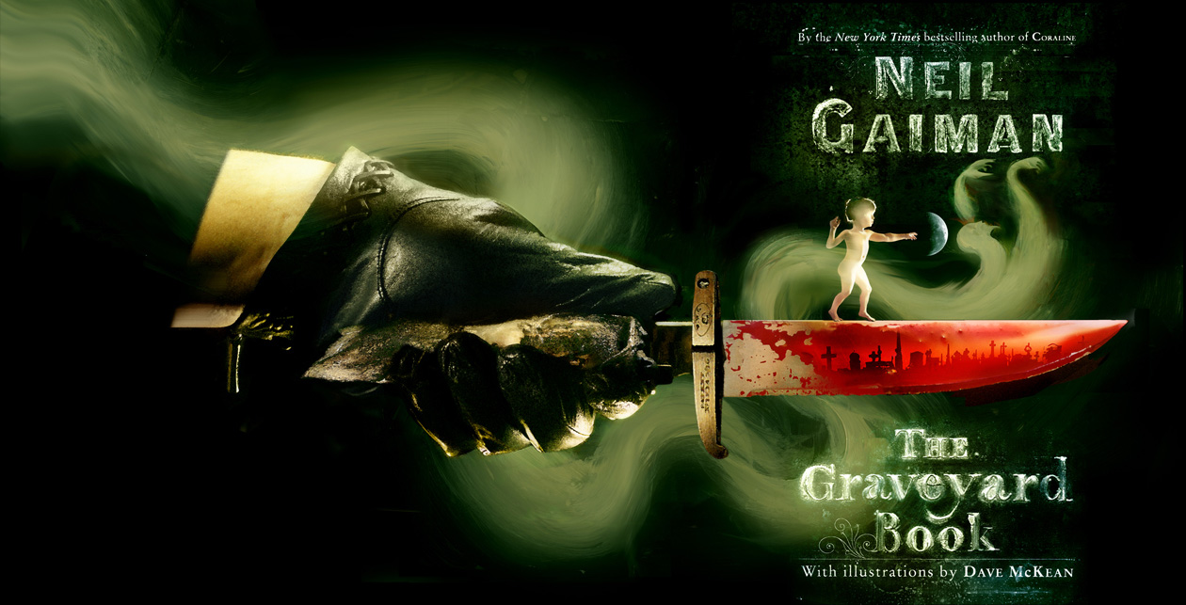
(Attention-Getter)
“There was a hand in the darkness, and it held a knife.”
(Intro)
The Graveyard Book is a fictional novel by Neil Gaiman, who also wrote Coraline.
(Body)
In this book, Neil Gaiman tells the story of Nobody Owens, known as Bod. On the night his parents are brutally murdered, 2 year old Bod calmly climbs out of his crib and toddles out of the house and into a nearby cemetery. There he is adopted by Mr. and Mrs. Owens (childless and dead for 250 years!) who gladly care for the child and protect him from harm.
With loving ghostly parents, teachers, friends, and protectors, Bod grows from age two to fifteen in the graveyard. He learns to read and do numbers, and he also learns some ghostly skills. But not all the residents of the graveyard are friendly. There are witches, ghouls and creatures and let’s not forget Jack – the evil fiend who is out to finish the job he started.
(Conclusion)
Filled with great illustrations, this is a funny, exciting and suspenseful story. How will Bod survive? Or will he? Can his loving family and friends really protect him from the evil Jack? This delightfully gruesome and very English tale will certainly appeal to both boys and girls who like adventure stories, suspense and some action. The Graveyard Book won the Newbery Award in 2009, and the awards said that the book is a “delicious mix of murder, fantasy, humour and human longing,” according to Diane Ferbrache, Hazen High School Librarian for The Washington Evergreen Young Adult Book Award, 2011

Rubric for Book Talk

Criteria | Excellent  10-9 | Above Average  8-7 | Average  6-5 | Below Average  4-0
Introduction attracts audience | Exceptionally creative beginning with an excellent quote | Creative beginning with a good quote | Not a very creative or interesting beginning with a quote | Not a very good beginning with no quote
Discusses the plot, setting, and characters  Discusses the theme | Thorough and interesting summary of these elements  Makes an insightful argument about the theme | Inconsistent summary of these elements  Correctly discusses theme but fails to elaborate on the importance | Average summary of the elements  Touches upon theme without much depth | Missing a component  Does not discuss theme or makes a very general statement about the theme
Conclusion makes us want to read the book (or not read the book) | Very enticing conclusion – draws the listener to read the book | Somewhat interesting conclusion- listener might want to read the book | Concluded but did not draw the listener to read the book | Very boring conclusion or no conclusion at all
Presentation skills  &  Enthusiasm for the book | Very enthusiastic and knowledgeable  Voice is clear, words are pronounced correctly and tempo is good  Maintains eye-contact | Somewhat enthusiastic and knowledgeable  Voice is mostly clear and audible,  Mostly maintains eye-contact | Shows average enthusiasm and understanding  Sometimes hard to understand or hear the student  Little eye-contact | Not enthusiastic at all  Spoken word is too soft, mumble, speaking much too fast or slow.  No eye-contact
Visual aid | Visual aid is well done, colorful, and very helpful to the presentation | Visual aid is colorful, and helpful to the presentation | Visual aid is completed and might be helpful to the presentation | Visual aid is not done or very poorly done

Stays within time limit: Yes / No

Comments: Score:

