Name: _________________________________________________ Date: ________
English 9 Period: ______
Outline for Constructed Response 4: Plot and Theme
Thesis Statement/Claim : What is the theme of Romiette and Julio by Sharon Draper? What aspect of PLOT develops the theme? How does it develop the theme? THIS NEEDS TO BE ONE SENTENCE LONG – use a semicolon or a comma and a coordinating conjunction.

Introduce your example with some background (one sentence)

Piece of Evidence #1 – Make sure it is what comes chronologically first in the text. Cite properly.

Reasoning – How does this piece of evidence show that PLOT develops the theme. You may need to use multiple sentences to hit on all of these things!

Use a transition word, then introduce your second example with some background (one sentence)

Piece of Evidence #2 – Make sure it is what comes chronologically last in the text.

Reasoning – How does this piece of evidence show that PLOT develops the theme. You may need to use multiple sentences to hit on all of these things!

Concluding sentence - Provide a concluding statement or section that follows from and supports the argument presented. (This is why ___ is the plot develops the theme DOES NOT COUNT). Your conclusion should include summary of your examples and how the theme applies outside of the text.

Transitional Words

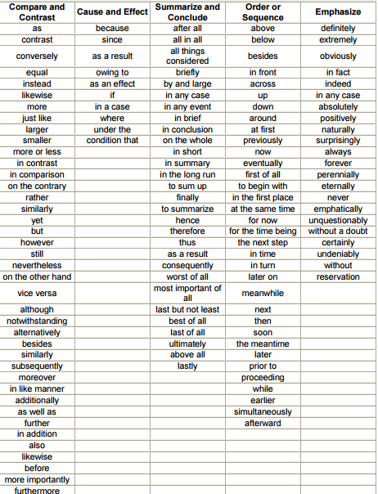

Constructed Response 4 – Plot and Theme
Prompt: What is a central theme in Romiette and Julio by Sharon Draper? How does the author use plot to develop this theme? Use at least two examples from the text.

3 points – Claim (Topic Sentence): Claim includes title of the text, author’s name, theme, and aspect of plot that develops the theme.
3 points – Topic Sentence: “For example,” provide a brief summary of events leading up to the example, etc.
3 points – Evidence– FROM Romiette and Julio: Supply sufficient relevant evidence from credible sources to fairly and thoroughly develop the claim. YOU MUST USE PROPER CITATIONS – Julio says, “Direct quote from the short story goes here” (Draper 11).
3 points – Reasoning: Use valid reasoning to explain how the evidence leads to the claim. Answer the questions: How does this piece of evidence prove that plot develops the theme? You may have to use more than one sentence to complete your reasoning.
3 points – Topic Sentence: Use a transition and then provide a brief summary of events leading up to the example, etc.
3 points – Evidence– FROM Romiette and Julio: Supply sufficient relevant evidence from credible sources to fairly and thoroughly develop the claim. YOU MUST USE PROPER CITATIONS – Julio says, “Direct quote from the short story goes here” (Draper 11).
3 points – Reasoning: Use valid reasoning to explain how the evidence leads to the claim. Answer the questions: How does this piece of evidence prove that plot develops the theme? You may have to use more than one sentence to complete your reasoning.
3 points – Conclusion: Provide a concluding statement or section that follows from and supports the argument presented. (This is why ___ is the most defining element DOES NOT COUNT). Your conclusion should include summary of your examples and how the theme applies outside of the text.
3 points – Use correct grammar, spelling, and punctuation. Introduce quotes, provide transitions where necessary, and use appropriate pronouns (no “I,” “me,” “my,” “you”, or contractions, capitalize proper nouns)

