Name: ___________________________________________ Date: ________

Honors English 12 Period: ___________

Kenning

**1.3.12.C:** Analyze the effectiveness of literary elements used by authors in various genres.

One of the literary devices popular in the Anglo-Saxon Old English poetry tradition is the kenning. Read the definition below and ready yourself to take a stab at this delightfully metaphorical way of speaking, writing, and thinking.

**kenning** - a literary device in which a noun is renamed in a creative way using a compound word or union of two separate words to combine ideas.

*If you call “school” a “scholar’s home” then you have created a kenning.  
**\***If you tell your friends that your parents are the “car loaners” then you have created a kenning.  
*The folks at Coca-Cola might agree that a cold Coke is "humanity’s beverage."

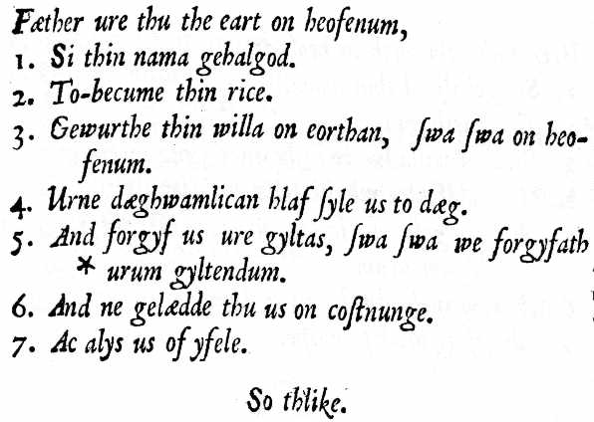**Assignment**: Consider carefully how you could creatively rename each of the following through the use of the kenning technique.  
  
1. a teacher: _____________________ 6. police: ____________________  
  
2. bus driver: ____________________ 7. Pop-tarts:__________________  
   
3. firemen: ______________________ 8. music:_____________________  
  
4. television: ____________________ 9. love: ______________________  
  
5. hamburger: ____________________ 10. computer:___________________