Ms. Aubrey
Aubrey
English 9
3 June 2015
MLA Guidelines – Comparative Analysis Essay
Your title should not be bold, underlined, or larger than the rest of your text. Do not add extra space between heading and title or title and the start of your essay.
After you have finished your writing and used MY EDITOR, please copy and paste your essay into a word document so that you can put it in proper MLA format. This will be the requirement for your essays in 10th grade.
Your essay should be entirely in Times New Roman, size 12 font. The spacing should be double spaced and you should go into Paragraph and click the box that says “do not add space between paragraphs of the same style.”
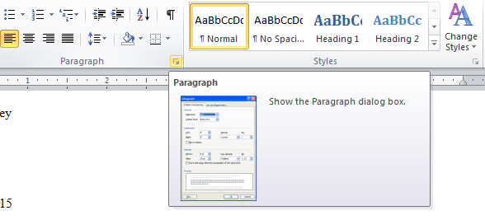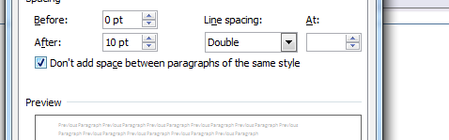
You need to have a running header at the top of the page that has your last name and the page number. You can do this by clicking the Insert tab and selecting Page Number, top of page, Plain Number 3. Write your last name in front of the page number and make sure that this, too, is in Times New Roman, size 12 font (see next page for graphics).
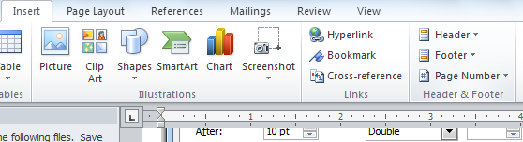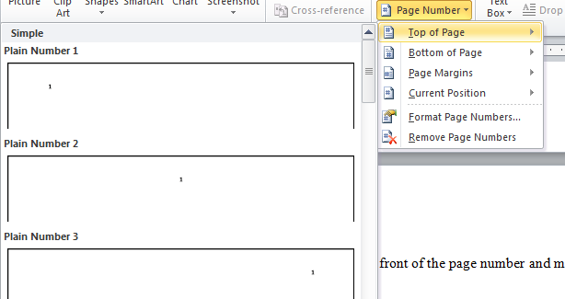
Your margins should be set to 1” each. Since you are citing more than one text, you will need to have a Works Cited page as the last page of your essay. When you are finished with your conclusion, hit enter until you come to the next page. At the top you should type Works Cited. This shouldn’t be bold, italicized, larger than the other text, etc. Next, you will list all of the sources you use in alphabetical order by author’s last name. You will have to have Romiette and Julio as well as your independent novel. Remember, an MLA citation looks like this:
Author’s Last Name, First Name. Title of the Novel. City Published: Publisher, Date Published.
Print.
There should be a hanging indent which means if the citation is longer than one line, you must indent the next line. Sometimes this means hitting enter at the end of the first line and then hitting tab for the second line. Please let me know if you have any questions.

Works Cited
Lee, Harper. To Kill a Mockingbird. New York: Warner Books, Inc., 1982. Print.
Shakespeare, William. Romeo and Juliet: A Parallel Text. Logan: Perfection Learning
Corporation, 1975. Print.

