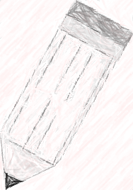
My Access Prompt – Choosing a Speaker for Your School

By today, you should have:
- Thesis Statement
- Body Paragraph 1
- Body Paragraph 2
- Body Paragraph 3

Today you should be working on
- Introduction (Hook and Topic Sentence/Background Information)
- Conclusion (Restate your thesis in new words, so what? Why does this matter?)

FIRST THINGS FIRST:
Look at what you’re writing
- MAKE SURE YOU ARE ANSWERING THE PROMPT Don’t just write about the life experiences of this person -- write about WHY THEY WOULD BE A GOOD SPEAKER FOR THE SCHOOL!
As you write/When you finish, remember we are writing academically, and look for the following things:
- NO first person (I, me, our, we, us, etc.)
- NO second person (you, your)
- NO contractions (if you don’t know what this means, google contractions!)
- Make sure you check for capitalization/punctuation
- Neshaminy High School is a proper noun, therefore N H and S must be capitalized.
- Avoid the word GOT (switch it out for a more academically appropriate word)

When you are done your draft, go to the top of the page and select My Editor and then select English. This will go through your writing and point out anything that My Access believes needs to be fixed. Some of this will be correct, some will not be. You must use your own discretion to decide, and/or call over Ms. Aubrey or Dr. Park to help!

