Name: _____________________________________
Period: ____________________
Ms. Aubrey
English
Getting Acquainted
Some of my friends call me by my nickname, ______________________________.
Right now, I am _______ years old, and my birthday is _________________________.
My best subject in school is _________________________________________ and my most difficult subject is ________________________________________________.
My favorite kind of music is ________________________________________.
My favorite song is _____________________________________.
My favorite after-school activity is _____________________________________.
One thing that makes me happy is __________________________________________________________________
_______________________________________________________________________________________________________________________________________________________________________________________________________________________________________________________________________________________________________________________________________
Someday, I hope to _____________________________________________________________________________________
______________________________________________________________________________________________________________________________________________________________________________________________________________________________________________________________________________________________________________________________________
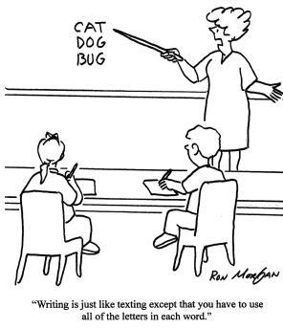
Now that I’ve told you my expectations of a good student, what are your expectations of a good teacher?

Tell me about the best teacher you’ve ever had. What made that person such a good teacher?

Now that I’ve told you some of my ideas about how we will go about learning this year’s material, tell me about how you learn best. Give me an example of a project or unit where you learned a lot. Describe the project in detail.

TICKET OUT: What is the message of the “Keep Moving Forward” clip, and how can you apply the message to your own school year?

