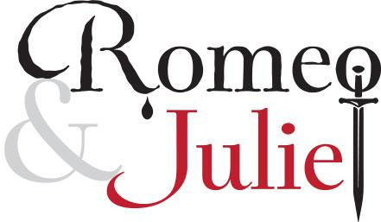

By William Shakespeare
English 9
“What makes or breaks a relationship?”

Background information,
Prologue, Act 1 and Act 2
Assessment: January 4th & 5th

Name: ________________________________

Topic/Objective: English Name:
Period:.
Activity / Lesson: Shakespeare - Background Date:

Essential Question: Who was WIlliam Shakespeare? How does an author’s life influence his/her work?

Questions/ Key Points  _______________________________________________________________________________________________________________________________________________________________________________  _______________________________________________________________________________________________________________________________________________________________________________  __________________________________________________________________________________________________________________________________________________________________________________________________________________________________________________________________________________________________________________________________________________________________________________________________________________________________________________________________ | Notes:  England in Shakespeare’s Day  Shakespeare = greatest writer/playwright in English language  Lived during Renaissance = science, commerce, philosophy, arts  Shakespeare’s literary career = reign of Queen Elizabeth (1558 – 1603)  Elizabeth = strong leader, supporter of English culture  Shakespeare wrote plays for Lord Chamberlain’s Men, a company sponsored by two men in high office.  Theater in Shakespeare’s Day  1590s = London was theater capital  Shakespearean theater was available and well-liked to rich and poor.  Globe Theater = poor stood / rich sat in balconies  No curtains, no artificial lighting, and little scenery = audience’s imagination  Only male actors / no women  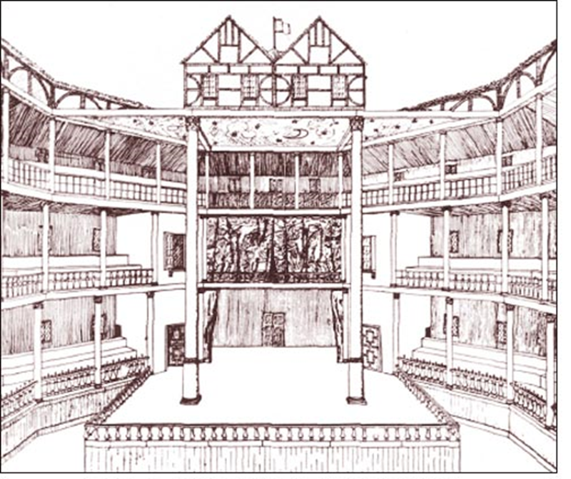  Shakespeare’s Impact on the EngLish Language  Shakespeare contributed more words, phrases and expressions to the English language than any other writer.  What are some words / phrases introduced by Shakespeare?  ________________ _______________ _________________  Other Notes:

Summary:
__________________________________________________________________________________________________________________________________________________________________________________________________________________________________________________
__________________________________________________________________________________________________________________________________________________________________________________________________________________________________________________
__________________________________________________________________________________________________________________________________________________________________________________________________________________________________________________
____________________________________________________________________________________________________________________________________________________________________________________________________________________________________________________________________________________________________________________________________________________________________________________________________________________________________________________________________________________________________
_________________________________________________________________________________________________________________________
VOCABULARY AWARENESS CHART
Shakespearean Terms

Word | Know it Well | Have Heard or Seen It | No Clue | Definitions/ Memorization Tool
Act
Allusion
Aside
Comic Relief
Dramatic Irony
Metaphor
Oxymoron
Scene
Soliloquy
Tragedy
Topic/Objective: English Name:
Period:.
Activity / Lesson: Shakespeare - sonnets Date:

Essential Question: What is a Shakespearean Sonnet?

Questions/ Key Points  _____________________________________________________________________________________________________________________________________________________________________________________________  _____________________________________________________________________________________________________________________________________________________________________________________________  __________________________________________________________________________________________________________________________________________________________________________________________________________________________________________________________________________________________________________________________________________________________________________________________________________________________________________________________________________________________________________________________________________________________________________________________________________________________________________________________________________________________________________________________________________________________________________________________________________________________________________________________________________________________________________________________________________________________________________________________________________________________________________________________________________________________________________________________________________________________________________________________________________________________________________________________________________________________________________________________________________________________________________________________________________________________________________________________________________________________________________________________________________________________________________________________________________________________________________________________________________________________________ | Notes:  Shakespearean sonnet: a 14 line stanza written in iambic pentameter, that employs the rhyme scheme abab, cdcd, efef,gg, and can be divided into three quatrains and a couplet.  Rhyme Scheme: the ordered pattern of rhymes at the ends of the lines of a poem or verse.  Example:  I don't want a lot for Christmas  There is just one thing I need  I don't care about the presents  Underneath the Christmas tree  I just want you for my own  More than you could ever know  Make my wish come true oh  All I want for Christmas is you  Iambic Pentameter: lines of poetry that can be divided into 5 metric feet with alternately unstressed and stressed syllables.  Example Outline/Rhyme Scheme/Meter Scan for Sonnet 18  Quatrain 1 (four-line stanza)  A Shall I | compare | thee to | a sum | mer's day?  B Thou art | more love | ly and | more temp | erate  A Rough winds | do shake | the dar |ling buds | of May  B And sum | mer's lease | hath all | too short | a date  Quatrain 2 (four-line stanza)  C Sometime too hot the eye of heaven shines  D And often is his gold complexion dimm’d  C And every fair from fair sometime declines  D By chance or nature's changing course untrimm’d  Quatrain 3 (four-line stanza)  E But thy eternal summer shall not fade  F Nor lose possession of that fair thou owest  E Nor shall Death brag thou wander'st in his shade  F When in eternal lines to time thou growest  Couplet (two rhyming lines)  G So long as men can breathe or eyes can see  G So long lives this and this gives life to thee

Summary:
__________________________________________________________________________________________________________________________________________________________________________________________________________________________________________________
__________________________________________________________________________________________________________________________________________________________________________________________________________________________________________________
__________________________________________________________________________________________________________________________________________________________________________________________________________________________________________________
__________________________________________________________________________________________________________________________________________________________________________________________________________________________________________________
The Prologue
(From Nofearshakespeare)
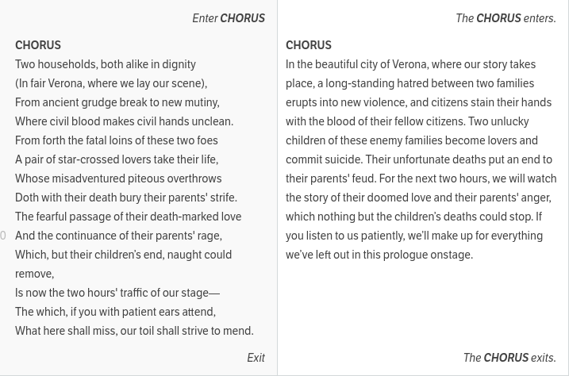
- The Chorus (kind of like a narrator) appears on stage and gives us the lowdown on the play we're about to watch (or read).
- The setting is "fair Verona," a town in Italy where two rival upper-crust families (the Capulets and the Montagues) have been feuding for as long as anyone can remember.
- We're also told how the children of these two families (that would be Romeo Montague and Juliet Capulet) will fall in love, but the story's not going to be a happy one. Before the play is over, our infamous "star-crossed lovers [will] take their life" (commit suicide), which will put an end to their parents' feud.
- Finally, the Chorus invites us to sit back and relax while we enjoy the "two-hours' traffic of [the] stage," which is sixteenth-century theater speak for "the next two hours it's going to take for the play to be performed."
- Brain Snack: In director Baz Luhrmann's 1996 film adaptation of the play (Romeo + Juliet), the Chorus is replaced by a TV anchorwoman who delivers the lines as an evening news story. (Shmoop.com)
USE YOUR RESOURCES!!
Romeo and Juliet
William Shakespeare
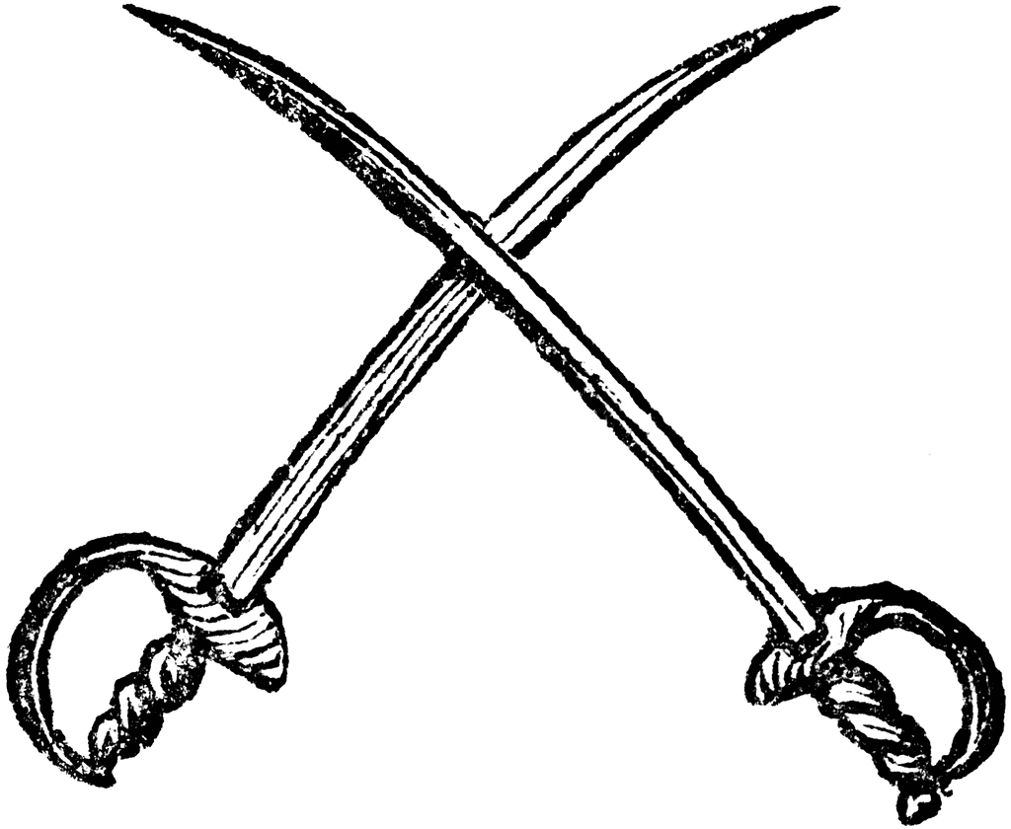
Act 1
ABRAHAM: Do you bite your thumb at us, sir?
SAMPSON: I do bite my thumb, sir.
ABRAHAM: Do you bite your thumb at us, sir?
SAMPSON, aside to Gregory: Is the law of our side, if I say "Ay"?
GREGORY, aside to Sampson: No.
SAMPSON: No, sir, I do not bite my thumb at you, sir, but I bite my thumb, sir. (1.1.45-52)

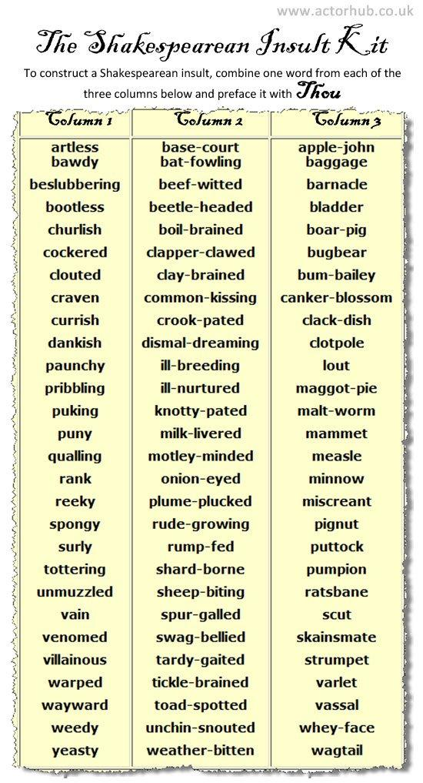
Topic/Objective: English Name:
Period:.
Activity / Lesson: Romeo and Juliet - Act 1, Scene 1 Date:

Essential Question: What makes or breaks a relationship? How do relationships shape values, actions, and lives? Should loyalty to family take precedence over all other aspects of life?

Questions/ Key Points  _____________________________________________________________________________________________________________________________________________________________________________________________  _____________________________________________________________________________________________________________________________________________________________________________________________  __________________________________________________________________________________________________________________________________________________________________________________________________________________________________________________________________________________________________________________________________________________________________________________________________________________________________________________________________________________________________________________________________________________________________________________________________________________________________________________________________________________________________________________________________________________________________________________________________________________________________________________________________________________________________________________________________________________________________________________________________________________________________________________________________________________________________________________________________________________________________________________________________________________________________________________________________________________________________________________________________________________________________________________________________________________________________________________________________________________________________________________________________________________________________________________________________________________________________________________________________________________________________ | Notes:  - On the streets of Verona, two young Capulet servants, Sampson and Gregory, are hanging out and trash-talking the Montagues. Those are some loyal servants.  - Then some young Montague servants (including Abraham) show up. Sampson and Gregory want to put their money where their mouths are, i.e., kick some Montague butt—but the Prince of Verona has laid out strict laws against starting fights.  - So, instead, they try to get the Montagues to start the fight.  - Sampson gives the Montagues the Elizabethan finger—he bites his thumb at them.  - Success. In about 0.5 seconds, they're fighting.  - Benvolio, the resident nice guy, shows up with a, "Why can't we all just get along?"  - But Tybalt, resident Capulet mean-guy, dashes in and says something like, "I'm going to get medieval on your…personage."  - Adding fuel to the fire, the remaining members of each of the families come out to join the fight, or "fray," as they called it back then.  - Like any good schoolyard brawl, some authority figure shows up and puts an end to the fun. In this case, it is the Prince of Verona. And he's m-a-d.  - He orders the Montagues and the Capulets to cease and desist. (Except it takes him a lot longer to say it, and he adds a supplement that anyone breaking his rule will be put to death.)  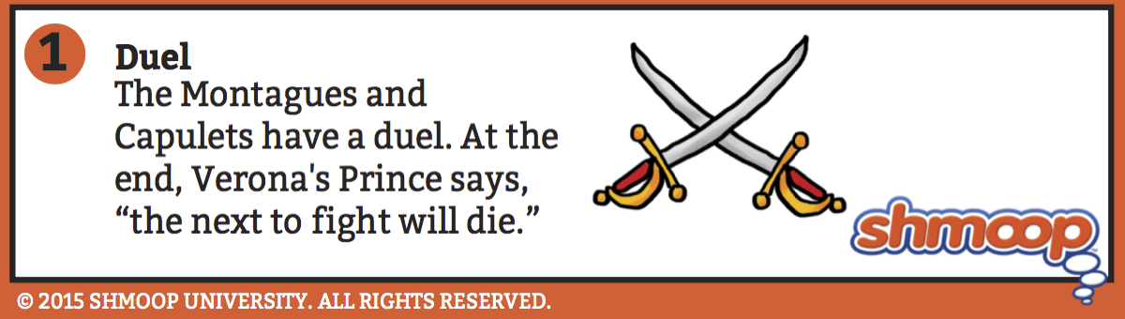  - BTW, Lord and Lady Montague say, has anyone seen their son, Romeo?  - Romeo, we find out, has been moping around in a "grove of sycamore," which, by the way, is Shakespeare's way of hinting that Romeo is lovesick or "sick amour." (Get it? Syc-a-more?)  - Not only that, says Benvolio, but Romeo never wants to hang out anymore.  - Montague chimes in, complaining that all Romeo ever does (when he's not skulking around in sycamore groves) is lock himself up in his dark "chamber" (bedroom).  - Yep, sounds like a lovesick teenager to us.  - Benvolio, like any good friend, decides to spy for Romeo's parents.  - Romeo wanders in and willingly tells Benvolio that he's in love with a girl who doesn't love him back. Cue Romeo's sighing, lamenting, and poetic musings.  - Romeo reveals that his unavailable crush has taken a vow of chastity and he boo-hoos about the fact that the still unnamed beautiful girl will never have any beautiful children..  - Benvolio tells his friend to get over it already, ugh. He says Romeo should look at other girls, but Romeo is skeptical. No one will compare. Benvolio disagrees and says he'll make Romeo forget his crush or die trying.

Summary:
__________________________________________________________________________________________________________________________________________________________________________________________________________________________________________________
__________________________________________________________________________________________________________________________________________________________________________________________________________________________________________________
__________________________________________________________________________________________________________________________________________________________________________________________________________________________________________________
__________________________________________________________________________________________________________________________________________________________________________________________________________________________________________________
Topic/Objective: English Name:
Period:.
Activity / Lesson: Romeo and Juliet - Act 1, Scene 2 Date:

Essential Question: What makes or breaks a relationship? How do relationships shape values, actions, and lives? Should loyalty to family take precedence over all other aspects of life?

Questions/ Key Points  _____________________________________________________________________________________________________________________________________________________________________________________________  _____________________________________________________________________________________________________________________________________________________________________________________________  ________________________________________________________________________________________________________________ | - Meanwhile, Lord Capulet is hanging out with County (a.k.a. Count) Paris, Verona's #1 most Eligible Bachelor.  - Capulet says something like "I'm getting too old for this whole family feud thing and so is Lord Montague—I'm sure we can work something out to keep the peace." (Get your highlighters out because this is pretty important. The whole Montague/Capulet feud may not be as big a deal to the older generation as it is to the younger generation.)  - But Paris has other things on his mind, like, "Hey, can I marry your thirteen-year-old daughter, Juliet?" Capulet says that his daughter's a little young—better wait until she's fifteen.  - Quick Brain Snack: In Shakespeare's day, the legal age of marriage was twelve for girls and fourteen for boys, but that doesn't mean people were running around getting married as pre-teens. In fact, most English people of the time married in their early twenties, just like now. Shakespeare was probably emphasizing how crazy these Italians were by making Juliet so young.  - Plus, he'd like Juliet to be on board with all this. But he says Paris can talk to his daughter at the annual Capulet bash that they're holding tonight at his house—maybe Juliet will fall in love with Paris. Age aside, it was totally normal for fathers to broker marriage deals without any input from their daughters, kind of like Montague is doing right now.  - Capulet gives one of his servants, Peter, a list of people to invite to the party. Unfortunately, the servant can't read. The illiterate servant decides to look for some people who can read.  - Romeo and Benvolio come in, still arguing about Romeo's unnamed love interest. (Don't worry, we'll find out this mystery girl's name soon enough.)  - The Capulets' servant asks them to read the guest list for the party. Guess who's on it? Capulet's "fair niece Rosaline." (Yep, that's Romeo's dream girl all right. She also happens to be a Capulet but Romeo doesn't seem to be worried that the big family feud will be a problem. What's up with that?)  - Romeo and Benvolio decide to crash the Capulet party. Romeo wants to see Rosaline and Benvolio wants to convince Romeo that she's not so special.

Summary:
__________________________________________________________________________________________________________________________________________________________________________________________________________________________________________________
__________________________________________________________________________________________________________________________________________________________________________________________________________________________________________________
_________________________________________________________________________________________________________________________
Topic/Objective: English Name:
Period:.
Activity / Lesson: Romeo and Juliet - Act 1, Scene 3 Date:

Essential Question: What makes or breaks a relationship? How do relationships shape values, actions, and lives? Should loyalty to family take precedence over all other aspects of life?

Questions/ Key Points  _____________________________________________________________________________________________________________________________________________________________________________________________  _____________________________________________________________________________________________________________________________________________________________________________________________  ______________________________________________________________________________________________________________________________________________________________________________________________________________________________________________________________________________________________________________________________________________________ | Notes:  - At the Capulet house, Juliet's mother, Lady Capulet, comes in to tell her daughter about Paris's proposal.  - But Juliet's nurse (who just gets called "Nurse" through the whole thing) first delivers a long, semi-bawdy speech about Juliet's infancy and toddler years. Her rambling, tangent of a speech reveals the following information: the Nurse had a baby named Susan who was about Juliet's age but, sadly, she died. The Nurse is not only Juliet's nanny but she also her wet-nurse. When it was time to "wean" (stop breastfeeding) Juliet, the Nurse put "wormwood" on her breast.  - Also, Juliet once fell down and cut her forehead when she was little, which the Nurse's late husband thought was hilarious—so hilarious that he turned the accident into a dirty joke.  - This is … a lot of information. Lady Capulet eventually cuts her off and tells her to "hold her peace."  - Lady Capulet unloads the news that Paris has been sniffing around for Juliet's hand in marriage. -- Eyeroll.  - Just check Paris out at the party that night, Lady Capulet says. He'll be the oh-so-dreamy guy all the other girls are swooning over.  - Speaking of, Peter, the servant, enters to announce that guests are beginning to arrive for the big bash.

Summary:
__________________________________________________________________________________________________________________________________________________________________________________________________________________________________________________
__________________________________________________________________________________________________________________________________________________________________________________________________________________________________________________
_________________________________________________________________________________________________________________________
Who’s Who in Verona

Two feuding factions: _________________ and ___________________
- Lord and Lady ________________ are the parents of _______________________ Capulet is the more ______________________ of the two lords.
- Lady Capulet is much more______________________________ than Lady Montague.
- Juliet’s cousin is named _____________________________. He is ____________________ and dislikes the Montagues.

- Lord and Lady ______________________ are the parents of ________________
- Montague hates______________________________, but did not teach this to Romeo.
- Lady Montague is ___________________.
- Romeo’s cousin is named ________________. He says he is ___________________, but he shows more sense than Romeo or Tybalt.

Neutral:
- _____________________, who is in charge of Verona, and his cousin, _______________________, one of Romeo’s friends.

And of course:
- ____________________________, the young Montague, is constantly_____________. _________________________, the young Capulet, is ____________________________, and does not dream of the honor of ___________________________________.

Topic/Objective: English Name:
Period:.
Activity / Lesson: Romeo and Juliet - Act 1, Scene 4 Date:

Essential Question: What makes or breaks a relationship? How do relationships shape values, actions, and lives? Should loyalty to family take precedence over all other aspects of life?

Questions/ Key Points  _____________________________________________________________________________________________________________________________________________________________________________________________  ___________________________________________________________________________________________________________________________________________________________________________________ | - Romeo and his posse (i.e., Benvolio and Mercutio) are getting ready to sneak into the Capulets' party. Luckily, it's a costume party, so they can wear masks. [We should point out that Mercutio's name was on the invite list, because he's not a Montague, but he feels the need to wear a mask anyway.]  - Romeo and Mercutio trade insults and there's some naughty talk about love, in particular. Mercutio's solution? "If love be rough with you, be rough with love. Prick love for pricking, and you beat love down."  - Romeo continues to boo-hoo about the unavailable Rosaline and then he announces that he had a dream the night before. Before he can go into the details, Mercutio interrupts and delivers a long, crazy speech about "Queen Mab," a tiny fairy who visits people in their dreams.  - Romeo says Mercutio is talking nonsense and Mercutio, our resident skeptic, retorts that dreams are for idiots.  - Before entering the party, Romeo says he has a feeling that "fate" may have something bad in store for him.  - According to Mercutio's vivid description, Queen Mab is a tiny fairy that rides around in a coach made out of an "empty hazelnut" with spider's "legs" for wheel spokes (1.4.72, 64). The coach is driven by an even tinier "grey-coated gnat" and drawn by a "team of little atomi" (tiny atoms).  - Queen Mab spends her time galloping over the noses and lips of sleepers, filling their dreams with wild fantasies (lovers dream of love, soldiers dream of slitting throats, lawyers dream of winning lawsuits, etc.). Mab is also kind of scary. When she's in a bad mood, she plagues women who dream of "kisses" with nasty sores ("blisters") that might just be cold sores.  - We need to think about what it is that prompts Mercutio's wild rant in the first place. Fed up with Romeo's lovesick moping for Rosaline, Mercutio taunts his buddy by saying that Queen Mab must have paid him a visit in the dream Romeo tries to tell him about. Mercutio also informs Romeo that dreams "are the children of an idle brain," which is another way of saying that Romeo is an idiot and his dreams about Rosaline are ridiculous (1.4.104). Given the context of the speech, it seems like Mercutio is suggesting that, like Queen Mab, dreams (especially Romeo's) are small and insignificant.

Summary:
__________________________________________________________________________________________________________________________________________________________________________________________________________________________________________________
__________________________________________________________________________________________________________________________________________________________________________________________________________________________________________________
Topic/Objective: English Name:
Period:.
Activity / Lesson: Romeo and Juliet - Act 1, Scene 5 Date:

Essential Question: What makes or breaks a relationship? How do relationships shape values, actions, and lives? Should loyalty to family take precedence over all other aspects of life?

Questions/ Key Points  ____________________________________________________________________________________________________________________________________________________________________________________________________________________________________________________________________________________________________________________________________________________________________________________________________________________________________________________________________________________ | - At the shindig, Capulet welcomes his guests to the party and invites everyone to get their groove on. He also threatens that if any young girl refuses to dance, he'll tell everyone she "hath corns" on her feet. (We're not kidding.)  - Now, for the moment we've all been waiting for. Romeo sees Juliet dancing and…falls in love at first sight. Rosaline who?  - Meanwhile, Tybalt, a.k.a., that dude who did all the fighting before (a.k.a., Juliet's easily angered cousin), recognizes Romeo.  - Tybalt tells Lord Capulet that he's going to beat up Romeo for crashing their party.  - Lord Capulet orders him to relax and leave Romeo alone—Romeo seems to be a nice enough kid. Plus, Lord Capulet wisely reasons that parties tend to get ruined by open brawls. Once the cops get called, everyone's fun is ruined.  - Tybalt just swears he'll make Romeo pay for this supposed insult later. Cue the dramatic and ominous music.  - Romeo approaches Juliet and delivers one of the coolest pickup lines to ever come out of the 16th century: "If I profane with my unworthiest hand this holy shrine, the gentle sin is this: My lips, two blushing pilgrims, ready stand to smooth that rough touch with a tender kiss." Translation: Your hand is clearly holy, so if I've offended you by touching it with my rough, unworthy hand, let me make things better with a kiss.  - Instead of getting annoyed and walking away, Juliet is intrigued. She banters back, telling him not to be so hard on himself. By holding her hand he's just showing devotion, the same way that pilgrims touch the hands of saints'. She also points out that placing their hands together, palm to palm, is like kissing. Romeo suggests that their lips should do what their hands are doing and gives her a kiss. (Count it: he says a total of 67 words to her before the lip-lock.)  - Juliet's nurse interrupts them and sends Juliet away, and Romeo asks her the name of the girl he's been kissing. And … she's a Capulet. Oops.The party starts breaking up. Juliet, who is already completely in love, asks her nurse to find out the identity of the first guy she has ever kissed. The answer: "His name is Romeo, and a Montague, the only son of your great enemy."  - Juliet is not too happy to hear this, but she still manages to be poetic about it: "My only love sprung from my only hate?"

Summary:
__________________________________________________________________________________________________________________________________________________________________________________________________________________________________________________
__________________________________________________________________________________________________________________________________________________________________________________________________________________________________________________
Romeo and Juliet – Act I Review

- What does the first scene of the play reveal about Romeo’s behavior? Explain how he changes by the end of Act I.
____________________________________________________________________________________________________________________________________________________________________________________________________________________________________________________________________________________________________________

- What is your impression of Juliet’s father? Describe the relationship between Capulet and his daughter as it is shown during Scene 2.
____________________________________________________________________________________________________________________________________________________________________________________________________________________________________________________________________________________________________________

- What concepts of love are presented by the female characters in Scene 3?
____________________________________________________________________________________________________________________________________________________________________________________________________________________________________________________________________________________________________________

- Characterize Mercutio as he appears in Scene 4. What kind of friend is he to Romeo?
____________________________________________________________________________________________________________________________________________________________________________________________________________________________________________________________________________________________________________

- What do you learn about Tybalt in Scene 5?
____________________________________________________________________________________________________________________________________________________________________________________________________________________________________________________________________________________________________________

- Analyze the behavior of Tybalt, Mercutio, and Benvolio in Act I. Based on your analysis, predict what their roles might be in the rest of the play.
____________________________________________________________________________________________________________________________________________________________________________________________________________________________________________________________________________________________________________

- Compare Romeo’s reaction to Juliet’s when each discovers the true identity of the other.
____________________________________________________________________________________________________________________________________________________________________________________________________________________________________________________________________________________________________________

Act I Review
Literary Elements

- A foil is a character in literature who has qualities that are in sharp contrast to another character, thus emphasizing the qualities of each. How is Mercutio a foil to Romeo?
____________________________________________________________________________________________________________________________________________________________________________________________________________________________________________________________________________________________________________

- Foreshadowing refers to hints in the text about what will occur later. What examples of foreshadowing do you find in the Prologue and in Scene 4 of Act I?

____________________________________________________________________________________________________________________________________________________________________________________________________________________________________________________________________________________________________________

- Hyperbole means obvious exaggeration. Look at Romeo’s declaration of love for Rosaline in Act I, Scene 1. What examples can you find of hyperbole? Why do you think he overstates his feelings?
____________________________________________________________________________________________________________________________________________________________________________________________________________________________________________________________________________________________________________

- Good drama has conflict: struggle between opposing forces. What conflicts are set in motion by events in Scene 5?
____________________________________________________________________________________________________
________________________________________________________________________________________________________________________________________________________________________________________________________

Romeo and Juliet
William Shakespeare
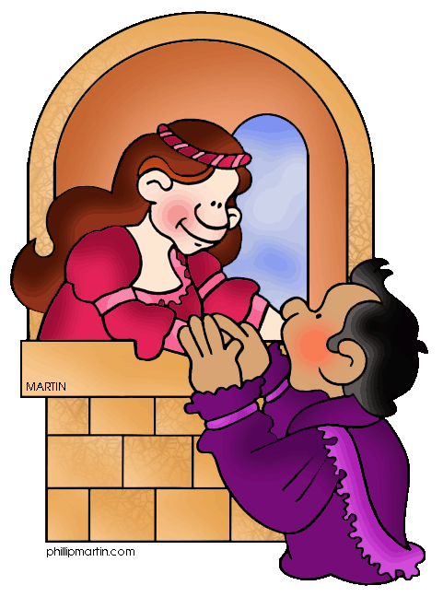
Act 2
“These violent delights have violent ends... Therefore love moderately. Long love doth so. Too swift arrives as tardy too slow.” – Friar Lawrence
Romeo and Juliet
Act II

“O Romeo, Romeo! Wherefore art thou Romeo?”

True or False

1. _______ Boys suffer over unrequited love as much as girls do.
REASONING:

2. _______ True love is worth the sacrifice of family and friends.
REASONING:

3. _______ Long engagements are better than short ones.
REASONING:

Before You Read:

- Watch for subtle changes in Romeo’s behavior. How does he develop during Act II?

- Early in Act II, Romeo risks discovery and death by entering the Capulet’s orchard in hopes of seeing Juliet. What are some up-to-date examples of “throwing caution to the wind” for love?

- The famous balcony scene takes place during Act II (Scene 2). It is traditionally staged with Juliet on a balcony outside her chamber, but was written with Juliet speaking from an upper chamber window – there was no balcony on the stage of Shakespeare’s theater.

Topic/Objective: English Name:
Period:.
Activity / Lesson: Romeo and Juliet - Act 2, Scene 1 Date:

Essential Question: What makes or breaks a relationship? How does age shape our perspective of love? Is it necessary to maintain a balance between emotion and reason?

Questions/ Key Points  _____________________________________________________________________________________________________________________________________________________________________________________________  _____________________________________________________________________________________________________________________________________________________________________________________________  ______________________________________________________________________________________________________________________________________________________________________________________________________________________________________________________________________________________________________________________________________________________ | Notes:  Prologue:  - The Chorus enters the stage and delivers a speech full of stuff you already know if you've been paying attention: Romeo has forgotten all about Rosaline and is now in love with the daughter of his enemy. Rosaline, whom he once said he'd die for, didn't stand a chance when compared to Juliet.  - What the Chorus adds, you probably could have guessed—namely that it's going to be hard for Romeo, a Montague, to get much quality time with Juliet, a Capulet. But...their passion makes them determined, and in time they'll find a way to meet up. Thanks, Chorus! Now we're ready to move on.  Act 2, Scene 1  - Romeo doesn't want to leave the Capulet's property, so he ditches his friends and hides out in the orchard behind the Capulet house.  - Benvolio and Mercutio try to find him. Unaware that Romeo now has the hots for Juliet, they shout lots of filthy things about Rosaline hoping that Romeo will come out to defend Rosaline's honor. No such luck.  - Eventually they give up and head home.

Summary:
__________________________________________________________________________________________________________________________________________________________________________________________________________________________________________________
__________________________________________________________________________________________________________________________________________________________________________________________________________________________________________________
_________________________________________________________________________________________________________________________
Topic/Objective: English Name:
Period:.
Activity / Lesson: Romeo and Juliet - Act 1, Scene 2 Date:

Essential Question: What makes or breaks a relationship? How does age shape our perspective of love? Is it necessary to maintain a balance between emotion and reason?

Questions/ Key Points  _____________________________________________________________________________________________________________________________________________________________________________________________  _____________________________________________________________________________________________________________________________________________________________________________________________  __________________________________________________________________________________________________________________________________________________________________________________________________________________________________________________________________________________________________________________________________________________________________________________________________________________________________________________________________________________________________________________________________________________________________________________________________________________________________________________________________________________________________________________________________________________________________________________________________________________________________________________________________________________________________________________________________________________________________________________________________________________________________________________________________________________________________________________________________________________________________________________________________________________________________________________________________________________________________________________________________________________________________________________________________________________________________________________________________________________________________________________________________________________________________________________________________________________________________________________________________________________________________ | Notes:  - Romeo is wandering aimlessly around the Capulet backyard when guess-who appears on the balcony. "What light through yonder window breaks?" he asks.  - He then answers his own question. "It is the East, and Juliet is the sun!"  - Just when you think Romeo is cray-cray, Juliet is talking to herself, too. "O Romeo, Romeo, wherefore art thou Romeo?" she asks.  - You might wonder, "why is she asking where Romeo is?" Well, as it turns out, "Wherefore" doesn't mean "where." It means "why." Juliet is saying, "Why does the guy I love have to be a Montague?"  - Juliet goes on talking to herself about how amazing Romeo is.  - Romeo is smart enough to keep his mouth shut and listen. Finally, he can't resist anymore, and he calls out to her.  - Juliet is super embarrassed until she realizes that it's Romeo hiding in the bushes. This is bad news, because if her family finds Romeo, they'll kill him.  - Luckily, she gets over her shock fast enough to enjoy the most romantic love scene in the history of Western literature.  - There's lots of poetry, vows of love that sound a lot like religious worship, baffling language, and teenage melodrama.  - Then Juliet basically proposes to Romeo when she says "If that thy bent of love be honourable, / Thy purpose marriage, send me word tomorrow." Translation: "If you love me and want to marry me, let me know ASAP."  - Romeo is game. They end up setting up a way to send messages the next day so they can plan the wedding.  - Eventually, Romeo and Juliet run out of things to talk about and start babbling just so they don't have to leave each other—kind of a "You hang up," "No, you hang up," deal.  - But, in Shakespearian terms, "You hang up" is actually "Parting is such sweet sorrow / That I shall say goodnight till it be morrow."  - If this went down 400 years later, these kids would be running off to Vegas together but, this being a Shakespeare play, Juliet finally drags herself away to bed and Romeo hightails it off to Friar Laurence, his favorite priest, to figure out the wedding plans.

Summary:
__________________________________________________________________________________________________________________________________________________________________________________________________________________________________________________
__________________________________________________________________________________________________________________________________________________________________________________________________________________________________________________
__________________________________________________________________________________________________________________________________________________________________________________________________________________________________________________
_________________________________________________________________________________________________________________________
Topic/Objective: English Name:
Period:.
Activity / Lesson: Romeo and Juliet - Act 2, Scene 3 Date:

Essential Question: What makes or breaks a relationship? How does age shape our perspective of love? Is it necessary to maintain a balance between emotion and reason?

Questions/ Key Points  Friar Laurence suggests that, depending on how it's used, a flower can be healing (because it's aromatic) or poisonous (if it's orally ingested). The Friar also muses that people are a lot like the flower he holds in his hand—being full of both "grace" and "rude will," human beings also have the capacity to be good or deadly, depending on whether or not "rude will" takes over. | - That Romeo sure is fast because the next thing we know, Romeo tracks down Friar Laurence, who has been out foraging for medicinal plants and herbs for one of his concoctions.  - Friar Laurence delivers a speech about how herbs and plants have the potential to be healing and medicinal, but if they're misused, they can be deadly poison..  - Friar Laurence looks at Romeo and notices that loverboy hasn't "been in bed tonight" and assumes that he must have finally hooked up with Rosaline. He also notices that Romeo is suddenly cheerful after weeks of moping around.  - Nope, he's totally over Rosaline and into this chick Juliet. Will Friar Laurence perform the ceremony? The Friar's response: "Holy Saint Francis!"  - Friar Laurence provides a much-needed reality check: Romeo has been switching girls like highway lanes.  - The Friar decides to help Romeo out but not because he's a romantic: he's got political motives—a marriage between Romeo and Juliet just might reconcile the two warring families.  - So, in the name of reducing the yearly street-brawl-murder rate in Verona, Friar Laurence skips the lecture on fidelity and commitment and goes right to agreeing with the marriage.

Summary:
__________________________________________________________________________________________________________________________________________________________________________________________________________________________________________________
__________________________________________________________________________________________________________________________________________________________________________________________________________________________________________________
_________________________________________________________________________________________________________________________

Topic/Objective: English Name:
Period:.
Activity / Lesson: Romeo and Juliet - Act 2, Scene 4 Date:

Essential Question: What makes or breaks a relationship? How does age shape our perspective of love? Is it necessary to maintain a balance between emotion and reason?

Questions/ Key Points  _____________________________________________________________________________________________________________________________________________________________________________________________  _____________________________________________________________________________________________________________________________________________________________________________________________  ______________________________________________________________________________________________________________________________________________________________________________________________________________________________________________________________________________________________________________________________________________________ | - Mercutio and Benvolio still haven't figured out where Romeo is.  - It turns out that Tybalt has sent Romeo a message that goes something like this: "I'm going to beat you up with my sword."  - But lovelorn Romeo is in no condition to face Tybalt in a duel, right?  - Of course Mercutio also uses the opportunity to take a dig at Tybalt, who takes himself and his sword fighting skills way too seriously.  - Romeo finally shows up, and he's dropped the depressed "Rosaline doesn't love me" act.  - The fellas engage in one of their favorite pastimes, talking trash and telling some of the dirtiest jokes in Western literature. You know, just a few bros chillin' together.  - As planned, the Nurse shows up to meet with Romeo. She looks ridiculous, apparently, and Mercutio can't resist flirting with her, mocking her, and talking dirty to her. He first says that the fan she's using should be used to cover her face since it's more attractive than she is.  - In between all these antics, Romeo manages to take the Nurse aside and tell her that Juliet should find an excuse to come to Friar Laurence's church—where she will be married.  - [FYI: Romeo's keeping his wedding plans from everyone (except the Nurse and Juliet), including his best friends.]

Summary:
__________________________________________________________________________________________________________________________________________________________________________________________________________________________________________________
__________________________________________________________________________________________________________________________________________________________________________________________________________________________________________________
_________________________________________________________________________________________________________________________

Topic/Objective: English Name:
Period:.
Activity / Lesson: Romeo and Juliet - Act 2, Scene 5 Date:

Essential Question: What makes or breaks a relationship? How does age shape our perspective of love? Is it necessary to maintain a balance between emotion and reason?

Questions/ Key Points  _____________________________________________________________________________________________________________________________________________________________________________________________  _____________________________________________________________________________________________________________________________________________________________________________________________  ______________________________________________________________________________________________________________________________________________________________________________________________________________________________________________________________________________________________________________________________________________________ | Notes:  - In an orchard at the Capulet place, Juliet waits for the Nurse to come back with a message from Romeo.  - When the Nurse comes back, she plays a little game by refusing to tell Juliet anything and complaining about her aching back.  - Finally, the Nurse gives in and tells Juliet to run to Friar Laurence's cell (a "cell" is just a room) where Romeo is waiting so they can get hitched.  - Before the scene ends, the Nurse says she'll "fetch a ladder" for Romeo to climb up so the lovers can spend their wedding night together.

Summary:
__________________________________________________________________________________________________________________________________________________________________________________________________________________________________________________
__________________________________________________________________________________________________________________________________________________________________________________________________________________________________________________
_________________________________________________________________________________________________________________________

Topic/Objective: English Name:
Period:.
Activity / Lesson: Romeo and Juliet - Act 2, Scene 6 Date:

Essential Question: What makes or breaks a relationship? How does age shape our perspective of love? Is it necessary to maintain a balance between emotion and reason?

Questions/ Key Points  _____________________________________________________________________________________________________________________________________________________________________________________________  _____________________________________________________________________________________________________________________________________________________________________________________________  ______________________________________________________________________________________________________________________________________________________________________________________________________________________________________________________________________________________________________________________________________________________ | Notes:  - Back at Friar Laurence's place, the priest tries to convince Romeo to calm down a little. Marriage is for the long term, you see. "These violent delights have violent ends," he warns.  - Unfortunately, it goes in one ear and out the other.  - Juliet runs in. The room's hormonal level skyrockets. Romeo and Juliet can barely keep their hands off each other, even in the presence of a priest.  - Friar Laurence takes them off to marry them..

Summary:
__________________________________________________________________________________________________________________________________________________________________________________________________________________________________________________
__________________________________________________________________________________________________________________________________________________________________________________________________________________________________________________
_________________________________________________________________________________________________________________________

Romeo and Juliet
Act II Review
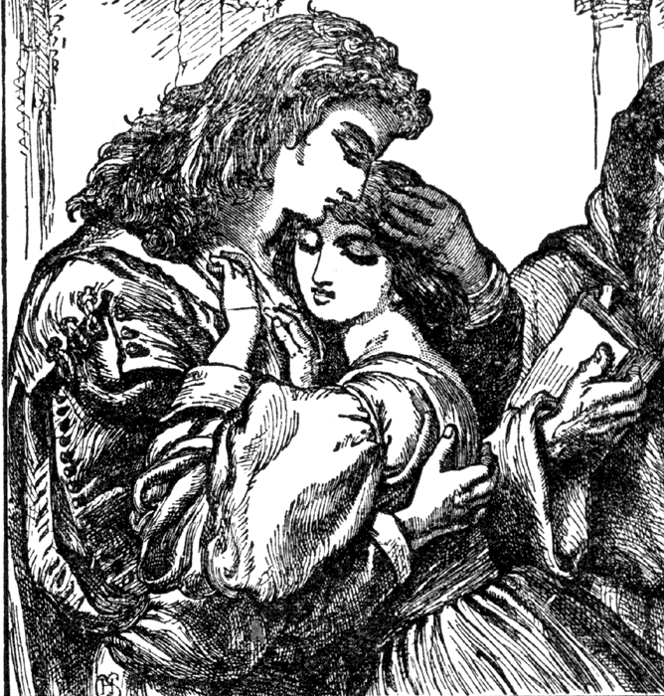

- What images of light and fire does Juliet inspire in Romeo? Provide two examples from Act II to support your response.

She is being compared to the sun and the stars!

- After exchanging vows of love in Scene 2, Juliet says, “I have no joy of this contract to-night.” What do you think she means by this? How does she feel? Find one example from Act II to support your response.

Juliet thinks they are moving too fast -- they are too rash.

- What philosophical observations does Friar Laurence make in Act II, Scene 3? Provide two examples to support your response.

Friar laurence believes that all things have good and bad qualities. He believes that plants can heal, but plants can be poison. The believes that humans can be good and still cause harm or they can bad and have a good heart.

- Describe in one word the interview between the Nurse and Romeo in Act II, Scene 4. Find two examples from this scene to support your response.

(reread)

- Do you approve of the Nurse and Friar’s action in helping with the secret wedding? Explain why or why not. Provide two examples to support your response.

(opinion)

- A metaphor is a direct comparison of unlike things without the use of like or as. Find an example of a metaphor in Scene 2. What emotions and attitudes does this metaphor help the young lovers express?
"It is the east, and Juliet is the sun" (2.2.3).metaphor - it compares Juliet to the sun
"O, speak again, bright angel!” metaphor - Romeo compares Juliet to a "bright angel"
"Thou know'st the mask of night is on my face..." (2.2.89). metaphor - compares the darkness of night to a mask
"This bud of love” metaphor - compares their love to a flower bud
"...I would have thee gone; -- and yet no farther than a wanton's bird, that lets it hop a little from her hand..." (2.2.189-191). metaphor - Juliet expresses how closely she wishes Romeo could stay to her by comparing him to a bird kept on a chain that can only "hop a little from her hand"

- Shakespeare allows his characters to reveal their innermost thoughts and feelings to the audience through speeches called soliloquies. Find soliloquies by Romeo and Friar Laurence in Act II. What purpose does each serve? Provide an example from each soliloquy to support your response.

Romeo - He reveals his feelings about Juliet outside of her Window
Friar Laurence - Plants -- being good and bad (Plants are like people in this).

- Imagery refers to language that appeals to the five senses (sight, hearing, taste, touch, and smell) and adds emotion and power to the writing. To see how imagery is used in the play, find examples of images of light, dark, and fire in Scene 2. What is each image’s dramatic purpose?

rising sun, bright angel, Night’s Cloak, Her Eyes are the Stars.

Student Questions:
Period 1:
Why is Tybalt a Lunatic? This is how Shakespeare characterizes him. He is Hot-Headed, Quick to fight, and thrives on the Fued of his family, the Capulets, and his rival family, The Montagues.
Why does Romeo love Juliet? They have known each other for a day. This is a question to which we do not know the answer, sometimes we must suspend reality when reading a book. They just do.
Why is Juliet getting married at 13? The legal age to get married at the time was 12 years old -- again, we must just accept that this was OK at the time, even though it is not OK now.
Why does Romeo ditch Rosaline/ Get over her so easily? Romeo was never dating Rosaline -- she wants to stay chaste her whole life. That is probably. why she was easy to forget when he saw Juliet.
Does Mercutio Really Die? How? YES - but not until Act 3 -- we will read on Monday.
Is the setting different between the movie and the book? YES! The book is set in the 1500s, the Movie is set in the 1990s.
Why do the Montagues and the Capulets hate each other? We don’t know how it started, we just know it has been going on for a long time.
Why would Mercutio take the Montagues to a Capulet party? They are just being crazy teenage boys crashing a party -- why wouldn’t he want his friends there?
How old is Romeo? We don’t know for sure, but it is alleged that he is 18-19.
Why does TYbalt want to fight Mercutio if he came for Romeo? This is in act 3, but Tybalt will fight anyone -- he is extremely hot headed. Mercutio is also fiercely loyal to Romeo.
Why does Juliet have feelings for Romeo even after finding out he is a Montague? The heart wants what the heart wants.
Who is Tybalt to Juliet? Tybalt is juliet’s first cousin. He is a capulet and also holds the title of “Prince of Cats”
Why didn’t Capulet care there was a Montague at his party? Capulet, in his old age, has no interest in continuing the feud -- he even says it should be easy for men as old as he and montague to keep the peace.

Period 2:
What Happens in Act 1? There is a street fight in Verona, the prince decrees that the next person to fight in the street will die. We meet Romeo -- he is depressed that the woman he is in love with, Rosaline, wishes to stay a virgin forever. Capulet tells Paris that he can marry Juliet if she is interested in Him. The Nurse is introduced as Juliet’s “second Mother” Lady capulet wants Juliet to Marry Paris because he is a good mate. The Montague men want to crash the Capulet party. Mercutio gives the Queen Mab speech about the fact that dreams are stupid. Romeo has a bad feeling about the events of that night. Romeo and the Montagues crash the capulet party. Tybalt is upset that Romeo is there and wants to fight him. Romeo and Juliet meet but are sad to find out that they are the children of enemies.
What Happens in Act 2? Romeo runs away from his friends so he can see Juliet -- he sneaks into her courtyard and stands outside of her window. They talk lovingly to each other and then plan to get married. We meet Friar Lawrence -- Romeo’s priest. Romeo tells him he wants to marry Juliet (Friar Lawrence is confused about what happened to Rosaline), but Friar Lawrence says yes so that he can hopefully mend the fued. We find out Tybalt has sent a written threat to Romeo and then Romeo makes plans with the nurse to set up the wedding. The nurse messes with Juliet when she brings back the news and then tells her to go to Friar Lawrence’s cell to be married. Romeo eagerly awaits Juliet’s arrival. The friar tells him “Violent delights have Violent ends”. Romeo and Juliet are married off stage between act two and act three.

What is Mercutio’s relationship to Romeo? mercutio is Romeo’s fiercely loyal friend. He is related to the prince (therefore, not a capulet or a montague).

Why are they getting married after a day? because they are crazy -- sometimes we have to suspend our reality to understand the text.

What would happen if the parents found out about the marriage? We don’t know, but we can infer it would not be good if they feel the need to sneak around.

What is Tybalt’s relationship to Juliet? Tybalt is juliet’s first cousin. He is a capulet and also holds the title of “Prince of Cats”

Why is Romeo not as involved in the fighting with the Capulets? Well now, he is in love with Juliet. He is more of a hopeless romantic than a fighter.

Why do we have to read Romeo and Juliet? 1. It is part of the curriculum. 2. It will make you a more analytical thinker. 3. it addresses themes that are still apparent today.

Period 6:
What Happens in Act 1? There is a street fight in Verona, the prince decrees that the next person to fight in the street will die. We meet Romeo -- he is depressed that the woman he is in love with, Rosaline, wishes to stay a virgin forever. Capulet tells Paris that he can marry Juliet if she is interested in Him. The Nurse is introduced as Juliet’s “second Mother” Lady capulet wants Juliet to Marry Paris because he is a good mate. The Montague men want to crash the Capulet party. Mercutio gives the Queen Mab speech about the fact that dreams are stupid. Romeo has a bad feeling about the events of that night. Romeo and the Montagues crash the capulet party. Tybalt is upset that Romeo is there and wants to fight him. Romeo and Juliet meet but are sad to find out that they are the children of enemies.

What Happens in Act 2? Romeo runs away from his friends so he can see Juliet -- he sneaks into her courtyard and stands outside of her window. They talk lovingly to each other and then plan to get married. We meet Friar Lawrence -- Romeo’s priest. Romeo tells him he wants to marry Juliet (Friar Lawrence is confused about what happened to Rosaline), but Friar Lawrence says yes so that he can hopefully mend the fued. We find out Tybalt has sent a written threat to Romeo and then Romeo makes plans with the nurse to set up the wedding. The nurse messes with Juliet when she brings back the news and then tells her to go to Friar Laurence's cell to be married. Romeo eagerly awaits Juliet’s arrival. The friar tells him “Violent delights have Violent ends”. Romeo and Juliet are married off stage between act two and act three.

What are the important names/people we should know? Romeo, Juliet, Lady Capulet, Capulet, Montague, Lady Montague, Tybalt, Benvolio, Mercutio, Nurse, Prince Escalus

Why do the Montagues and the Capulets hate each other? We don’t know how it started, we just know it has been going on for a long time.

Why don’t the parents care how their children feel? The parents don’t KNOW how their children feel -- the the kids are afraid to tell their parents, so they have their secret wedding where only the nurse and friar laurence know about it.

What happened at the beginning of Act 2? Act 2, scene 1 - Romeo avoids his friends after the Capulet party because they do not understand him. Act 2, scene 2 - Romeo waits outside of the Capulet house to see Juliet. This is when the balcony scene happens and Romeo and Juliet decide to get married.

What happens in the last scene? IN Act 2, Scene 6, Friar Laurence is trying to calm Romeo before his wedding. This is where the friar warns Romeo to love each other with Moderation -- “These Violent Delights have Violent Ends”. Juliet arrives and the two are married off stage in between the second and third act.

Why does romeo like Juliet? From the text, all we know is that he likes her because she is beautiful. They barely speak to each other before deciding to get married.

