Name: ____________________________ Date: ____
Honors English 12 Period: __

Percy Bysshe Shelley
(1792 – 1822)

What Percy Bysshe Shelley did... and why you should care
"Even in modern times, no living poet ever arrived at the fullness of his fame," the poet Percy Bysshe Shelley wrote. "[T]he jury which sits in judgment upon a poet, belonging as he does to all time, must be composed of his peers; it must be impanelled by Time from the selectest of the wise of many generations."¹
With these words, Shelley unwittingly wrote his own biography and epitaph. Percy Bysshe Shelley was dead within a year of penning those sentences, the victim of a boating accident at age 29. When he died, only a few dozen people had ever read his poetry. His literary talents were eclipsed by those of his friend and rival, the poet Lord Byron, and occasionally by his wife Mary Shelley, the author of Frankenstein. He was seen as an impractical dreamer, a wimp, a man of dubious morals.
Yet now, nearly 200 years after his untimely death, we see Percy Bysshe Shelley as a hero of English Romanticism. His verses are full of lyricism and beauty, pulsing with the vitality for which he was known during his life. Though his methods were unconventional, in his poetry and life Shelley strove for a more beautiful and true world. Percy Bysshe Shelley "kept your brain in constant action," a friend of his wrote after his death. He continues to do so today.

Brain Snacks: Tasty Tidbits of Knowledge
- When he was nineteen, Shelley wrote a pamphlet entitled "Declaration of Rights." To get the missive out to as many people as possible, he bottled some of the copies and tossed them in the sea. Others he launched via balloons.
- As a student at Eton, Shelley sometimes engaged in the decidedly un-Romantic pastime of setting trees on fire using sunlight and glass.
- Shelley was said to have hunched posture and a narrow chest as a result of a lifetime of bending over books.
- Shelley was a vegetarian.
- When Shelley fell in love with Mary Godwin, he suggested to his current wife Harriet Westbrook that the three of them live together, with Mary as his new wife and Harriet as his sister. Harriet didn't go for that. We can't imagine why.
- Shelley could be a bit absent-minded. If he couldn't remember whether he'd eaten that day, he'd call out to his wife, "Mary, have I dined?" When he did bother to eat he usually did it standing up, while reading a book.
- Shelley's body was identified when it washed ashore by the copy of Keats' Lamia that he carried in his pocket.
- When Percy Bysshe Shelley was cremated, his heart would not burn, possibly because of a health condition that caused its calcification. His friend Edward Trelawny removed it from the fire and gave it to Mary Shelley. Legend has it she kept the crumbled remains in her desk. The remains of the heart were buried with Shelley's son, Percy Florence.
"A poet is a nightingale, who sits in darkness and sings to cheer its own solitude with sweet sounds." – Percy Shelley, “A Defense of Poetry”

Shmoop Editorial Team. "Percy Bysshe Shelley." Shmoop. Shmoop University, Inc., 11 Nov. 2008. Web. 26 Dec. 2015.
,.
from “A Defense of Poetry”
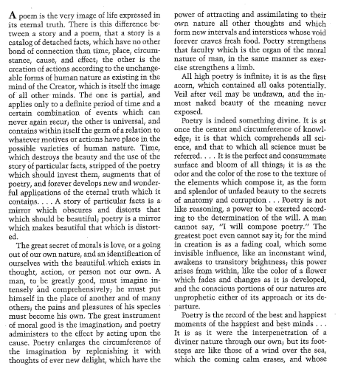
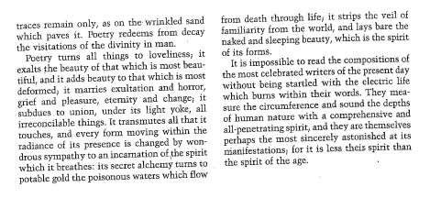

Getting at Meaning:
- According to Shelley, why a poem superior to prose?

- From where does the inspiration for poetry come according to Shelley (from the outside, from the inside, both?) Highlight evidence from the text to support your answer.

- THEME: Compared with the Puritan view that nature is essentially corrupt, what would you say is Shelley’s view of human nature? Of all creation? What concept of the deity is implied in this selection? How does Shelley seem to conceive the role of the poet in society?

“Ozymandias”

In A Nutshell
Late in 1817 Percy Shelley and his friend Horace Smith decided to have a sonnet competition – that's right folks: a sonnet competition! For the subject of their sonnets, Shelley and Smith chose a partially-destroyed statue of Ramses II ("Ozymandias") that was making its way to London from Egypt, finally arriving there sometime early in the year 1818. In the 1790's Napoleon Bonaparte had tried to get his hands on the statue, but was unable to remove it from Egypt. That's partly because it weighs almost 7.5 tons. Shelley, like Napoleon, was fascinated by this giant statue.
While Shelley has a reputation for radical and experimental poetry, "Ozymandias" is a pretty "tame" poem compared to many of his other works; it is written in a well-known and widely-used form – a fourteen-line sonnet – and doesn't say anything too offensive like "We should all be atheists" (Shelley was expelled from Oxford for writing a pamphlet advocating just this).

WHY SHOULD I CARE?
Why read this poem? As a sonnet, it has only fourteen lines, but in this limited space, Shelley explores a number of issues with enduring relevance. "Ozymandias" explores the question of what happens to tyrant kings, and to despotic world leaders more generally. As we all know, nothing lasts forever; that means even the very worst political leaders – no matter how much they boast – all die at some point. If Shelley were writing this poem now, he might take as his subject the famous statue of Saddam Husseinthat was pulled down after the dictator was overthrown. Like the fallen statue in Baghdad, the broken-down statue of Ozymandias in Shelley's poem points to the short-lived nature of political regimes and tyrannical power.
But, Shelley doesn't just come out and say "nothing lasts forever" and "there is always hope." He writes a sonnet with a really cool rhyme scheme. Just try reading the poem out loud, and you'll see what we mean.
Shmoop Editorial Team. "Ozymandias." Shmoop. Shmoop University, Inc., 11 Nov. 2008. Web. 26 Dec. 2015.

Ozymandias
I met a traveller from an antique land
Who said: Two vast and trunkless legs of stone
Stand in the desert. Near them on the sand,
Half sunk, a shatter'd visage lies, whose frown
And wrinkled lip and sneer of cold command
Tell that its sculptor well those passions read
Which yet survive, stamp'd on these lifeless things,
The hand that mock'd them and the heart that fed.
And on the pedestal these words appear:
"My name is Ozymandias, king of kings:
Look on my works, ye Mighty, and despair!"
Nothing beside remains: round the decay
Of that colossal wreck, boundless and bare,
The lone and level sands stretch far away.
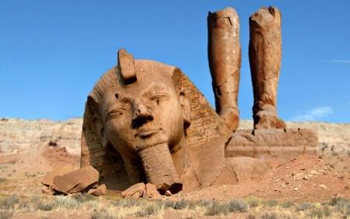

Bring on the tough stuff - there’s not just one right answer.
- Where do you think the encounter between the speaker and the traveler takes place? Is it on the street? Is it in the speaker's head? What does this vagueness contribute to the poem?

- In this poem three different people speak (the speaker, the traveler, and Ozymandias). What do you make of this? Does it make the poem seem more like a novel or a play, where different voices are permitted to speak?

- There's a lot of alliteration in this poem. There's also plenty of rhyming. What do you make of all this repetition? Does it suggest some kind of cyclical, history-repeats-itself, idea?

- What do you think Ozymandias would say if he could see what has happened to his crumbling statue? Would he be humbled or would he find some other way to boast?

- Are there political leaders today that you consider to be similar to Ozymandias, or is he a different case because he had absolute power? Which leaders would you want to read this poem?

